**SMART HEALTH MONITORING SYSTEM**

***Submitted by***

**KRISHITAA BALAMURALI (RA2011003010115)**

**PUTTA SRI NAGA SANJANA (RA2011003010123)**

**AADIT TRIVEDI (RA2011003010127)**

***Under the Guidance of***

**Dr.T.K.SIVAKUMAR**

**Asst.Prof.(Sr.Grade) / Computing Technologies**

***In partial satisfaction of the requirements for the degree of***

## **BACHELOR OF TECHNOLOGY**

**in**

**COMPUTER SCIENCE ENGINEERING**

**SCHOOL OF COMPUTING**

# **COLLEGE OF ENGINEERING AND TECHNOLOGY**

**SRM INSTITUTE OF SCIENCE AND TECHNOLOGY**

**KATTANKULATHUR - 603203**

**JULY 2022**

SRM INSTITUTION OF SCIENCE AND TECHNOLOGY

KATTANKULATHUR-603203

**BONAFIDE CERTIFICATE**

Certified that this lab report titled **“SMART HEALTH MONITORING SYSTEM”** is the bonafide work done by KRISHITAA BALAMURALI (RA2011003010115), PUTTA SRI NAGA SANJANA (RA2011003010123), AADIT TRIVEDI (RA2011003010127) who carried out the **18CSC206J - SOFTWARE ENGINEERING AND PROJECT MANAGEMENT** lab exercises under my supervision. Certified further, that to the best of my knowledge the work reported herein does not form part of any other work.

| **Staff-in-charge**  **Dr.T.K.SIVAKUMAR**  **Asst.Prof.(Sr.Grade) / Computing Technologies** | **HEAD OF THE DEPARTMENT**  **Dr. M. Pushpalatha, Professor Dept. of Computing Technologies** |
| --- | --- |

University Examination held on …………..………….

**INTERNAL EXAMINAR – 1 INTERNAL EXAMINAR -2**

**ABSTRACT**

In many countries, especially in under developed and developing countries proper health care service is a major concern. The health centers are far and even the medical personnel are deficient when compared to the requirement of the people. For this reason, health services for people who are unhealthy and need health monitoring on regular basis is like impossible. This makes the health monitoring of healthy people left far more behind. In order for citizens not to be deprived of the primary care it is always desirable to implement some system to solve this issue. The application of PHP is a fast and feature-rich open source scripting language and MySQL is a powerful open source database server built based on a relational database management system (RDBMS) and is capable of handling a large concurrent database connection. They have been implemented in various areas like security, intelligent transport system, smart cities, smart factories and health. The proposed architecture can be used to acknowledge the underlying problem of deficient clinic-centric health system and change it to smart patient- centric health system. The main function of the system is register and store patient details and doctor details and retrieve these details as and when required, and also to manipulate these details meaningfully System input contains patient details, diagnosis details, while system output is to get these details on to the screen.

**TABLE OF CONTENTS**

| **CHAPTER NO** | **TITLE** | **DATE** | **PAGE No** |
| --- | --- | --- | --- |
|  |  |  |  |
|  | **ABSTRACT** |  | **iii** |
|  | **LIST OF FIGURES** |  | **v** |
|  | **LIST OF ABBREVIATIONS** |  | **vi** |
| **1** | **PROBLEM STATEMENT** | **15.03.2022** | **1** |
| **2** | **STAKEHOLDERS & PROCESS MODELS** | **22.03.2022** | **4** |
| **3** | **IDENTIFYING REQUIREMENTS** | **29.03.2022** | **8** |
| **4** | **PROJECT PLAN & EFFORT** | **05.04.2022** | **12** |
| **5** | **WORK BREAKDOWN STRUCTURE & RISK ANALYSIS** | **12.04.2022** | **16** |
| **6** | **SYSTEM ARCHITECTURE, USE CASE & CLASS DIAGRAM** | **21.04.2022** | **23** |
| **7** | **ENTITY RELATIONSHIP DIAGRAM** | **06.05.2022** | **27** |
| **8** | **DATA FLOW DIAGRAM** | **13.05.2022** | **34** |
| **9** | **SEQUENCE & COLLABORATION DIAGRAM** | **20.05.2022** | **40** |
| **10** | **DEVELOPMENT OF TESTING FRAMEWORK/USER INTERFACE** | **27.05.2022** | **44** |
| **11** | **TEST CASES & REPORTING** | **11.06.2022** | **47** |
| **12** | **ARCHITECTURE/DESIGN/FRAMEWORK/IMPLE-MENTATION** | **17.06.2022** | **52** |
|  | **CONCLUSION** |  | **85** |
|  | **REFERENCES** |  | **86** |
|  | **APPENDIX (CODE)** |  | **58** |

**LIST OF FIGURES**

| **FIGURE NO** | **TITLE** | **PAGE NO** |
| --- | --- | --- |
| Figure 5.1  Figure 5.2  Figure 5.3  Figure 6.1  Figure 6.2  Figure 6.3  Figure 7.1  Figure 8.1  Figure 8.2  Figure 8.3  Figure 9.1  Figure 9.2 | Work Breakdown Structure  Timeline-Gantt Chart  SWOT Analysis and RMMM  System Architecture  Class Diagram  Use Case Diagram  ER Diagram  DFD Level 0  DFD Level 1  DFD Level 2  Sequence Diagram  Collaboration Diagram | 17  19  20  24  25  26  28  35  36  37  40  41 |
|  |  |  |
|  |  |  |
|  |  |  |
|  |  |  |

**LIST OF ABBREVIATIONS**

|  |  |
| --- | --- |
| **SHORT FORM** | **FULL FORM** |
| WBS | Work Breakdown Structure |
| DFD | Data Flow Diagram |
| ER | Entity Relationship |
| COCOMO | Constructive Cost Model |
| SWOT | Strength, Weakness, Opportunities, Threats |

|  |
| --- |
|  |
|  |
|  |

CHAPTER – 1

**Course Code : 18CSC206J**

**Course Name: Software Engineering and Project Management**

|  |  |
| --- | --- |
| **Experiment No** | 1 |
| **Title of Experiment** | To identify the Software Project, Create Business Case, Arrive at a Problem Statement |
| **Name of the candidate** |  |
| **Team Members** | Aadit Trivedi, Putta Sri Naga Sanjana , Krishitaa Balamurali |
| **Register Number** |  |
| **Date of Experiment** | 15/03/2022 |

## Mark Split Up

|  |  |  |  |  |  |
| --- | --- | --- | --- | --- | --- |
| **S.No** |  | **Description** |  | **Maximum Mark** | **Mark Obtained** |
| 1 | Exercise |  |  | 5 |  |
| 2 | Viva |  |  | 5 |  |
|  |  |  | **Total** | **10** |  |

**Team Members:**

|  |  |  |  |
| --- | --- | --- | --- |
| **S. No** | **Register No** | **Name** | **Role** |
| **1** | **RA2011003010127** | **Aadit Trivedi** | **Lead/Rep** |
| **2** | **RA2011003010115** | **Krishitaa Balamurali** | **Member** |
| **3** | **RA2011003010123** | **Putta Sri Naga Sanjana** | **Member** |

## Aim

To Frame a project team, analyze and identify a Software project. To create a business

case and Arrive at a Problem Statement for the <title of the project>

**Project Title:** Smart Health Monitoring System

## **Project Description:** It is a online health monitoring system. The proposed architecture can be used to acknowledge the underlying problem of deficient clinic-centric health system and change it to smart patient- centric health system. The main function of the system is register and store patient details and doctor details and retrieve these details as and when required, and also to manipulate these details meaningfully System input contains patient details, diagnosis details, while system output is to get these details on to the screen.

Business Case

<Incorporate the Business Case template>

# **ONE PAGE BUSINESS CASE TEMPLATE**

|  |  |
| --- | --- |
| **DATE** | 08/03/2022 |
| **SUBMITTED**  **BY** | AADIT TRIVEDI, KRISHITAA BALAMURALI, PUTTA SRI NAGA  SANJANA |
| **TITLE / ROLE** | A Smart Health Monitoring System |

**THE PROJECT**

In bullet points, describe the problem this project aims to solve or the opportunity it aims to develop.

->

A system which allows users to get instant guidance on their health issues through an

intelligent health care system online.

->

It is a HealthMonitoring System using Machine Learning.

**THE HISTORY**

In bullet points, describe the current situation.

->

Due to the Pandemic situation, people couldn’t go to the hospitals for regular health

checkups.

->

Often people don’t get time to go to the hospital.

->

There maybe situations where the patient needs immediate help from doctor but the

respective doctor is not available.

**LIMITATIONS**

List what could prevent the success of the project, such as the need for expensive equipment, bad weather, lack

of special training, etc.

->

Doctors are unsure whether to recommend health apps.

->

Health apps can never be too accurate to replace the human mind & judgements.

->

The illiterate section of society lacks the knowledge & skill to use the app.

**APPROACH**

List what is needed to complete the project.

Identifying the right problem to be solved.

->

->

Making sure the app is convenient to use.

->

Doing market analysis.

->

Making sure the app is secured.

**BENEFITS**

In bullet points, list the benefits that this project will bring to the organization.

-> Remote assistance, Effective workload distribution, Brand Awareness for Doctors.

-> Good Treatment, Cost-efficiency, Online Payment, Remote assistance for patients.

**Result:**

Thus, the project team formed, the project is described, the business case was prepared and the problem statement was arrived.

CHAPTER – 2

**Course Code: 18CSC206J**

**Course Name: Software Engineering and Project Management**

|  |  |
| --- | --- |
| **Experiment No** | 2 |
| **Title of Experiment** | To identify the stakeholders and make a stakeholder register. |
| **Name of the candidate** |  |
| **Team Members** | Aadit Trivedi, Putta Sri Naga Sanjana , Krishitaa Balamurali |
| **Register Number** |  |
| **Date of Experiment** | 22/03/2022 |

### Mark Split Up

|  |  |  |  |
| --- | --- | --- | --- |
| **S.No** | **Description** | **Maximum Mark** | **Mark**  **Obtained** |
| 1 | Exercise | 5 |  |
| 2 | Viva | 5 |  |
|  | **Total** | **10** |  |

**Team Members:**

|  |  |  |  |
| --- | --- | --- | --- |
| **S. No** | **Register No** | **Name** | **Role** |
| **1** | **RA2011003010127** | **Aadit Trivedi** | **Lead/Rep** |
| **2** | **RA2011003010115** | **Krishitaa Balamurali** | **Member** |
| **3** | **RA2011003010123** | **Putta Sri Naga Sanjana** | **Member** |

HOW TO IDENTIFY STAKEHOLDERS

* Who is affected positively and negatively by the project?

ANS. Positive Effect : Hospitals, patients who have basic knowledge about using gadgets, project team members.

Negative Effect: Patients who don’t have basic knowledge about using gadgets , small clinics .

* Who has the power to make it succeed (or fail)?

ANS. Project team members, good reception from doctors and patients will make the project successful.

* Who makes the decisions about money?

ANS. The project team members along with some consultation from the mentor (in this case teacher) of the project make decisions about money.

* Who are the suppliers?

ANS. Suppliers are those stakeholders that affect the successful accomplishment of a project through providing goods/services. They are paid for the contribution.

* Who are the end users?

ANS. An end user is a person or other entity that consumes or makes use of the goods or services produced by businesses. So in this case the patients and doctors using the application are the end users.

* Who has influence over other stakeholders?

ANS. They can be both internal – shareholders, employees, the chief executive and board of directors – and external – customers. Secondary stakeholders have an indirect influence – **government agencies, suppliers, local communities**. In this case hospital authorities , doctors are internal influencers and external influencers is the product users i.e. the patient.

* Who could solve potential problems with the project?

ANS. Government and Doctors can solve potential problems

with the help of this project.

* Who is in charge of assigning or procuring resources or facilities?

|  |  |  |  |  |
| --- | --- | --- | --- | --- |
| PROJECT NAME: A Smart Health Monitoring System | | |  |  |
| PREPARED BY: Aadit Trivedi, Putta Sri Naga Sanjana, Krishitaa Balamurali | | |  |  |
| DATE: 15/03/22 | | |  |  |
| PROJECT STAKEHOLDER NAME | SPECIFIC  INFORMATION  NEEDS | PROJECT INTERESTS | IMPACT ON PROJECT | ROLE |
| Types And Frequency of communication | Specific Areas Of  Interest And  Participation | Positive, Negative,  Influencer,  Supporter,  Roadblock | Decisionmaker,  Collaborator,  Participant,  Consultant,  Information  Recipient |
| Aadit Trivedi | Email and mobile Frequency: Twice a  week | Area of interest: To help in improving the health of citizens.  Participation: Active | Positive | Participant,  Decisionmaker |
| Putta Sri Naga Sanjana | Email and mobile Frequency: Twice a  week | Area of interest: To study about online consultation and monitoring systems. | Positive | Participant,  Decisionmaker |

ANS. The project members are in charge of assigning and procuring resources and facilities.

* Who has specialist skills which are crucial to the project? ANS. Different group members bring on board different skills such as python, machine learning etc.

## STAKEHOLDER REGISTER

|  |  |  |  |  |
| --- | --- | --- | --- | --- |
|  |  | Participation: Active |  |  |
| Krishitaa Balamurali | Email and mobile Frequency: Twice a  week | Area of interest: To study countless  possibilities for hidden pattern investigation from these data sets  Participation: Active | Positive | Participant,  Decisionmaker |
| Teacher | Email and mobile Frequency: Once a  week | Participation: Active | Positive, Influencer,  Supporter | Consultant,  Information  Recipient |

CHAPTER - 3

**Course Code: 18CSC206J**

**Course Name: Software Engineering and Project Management**

|  |  |
| --- | --- |
| **Experiment No** | 3 |
| **Title of Experiment** | To identify the Requirements |
| **Name of the candidate** |  |
| **Team Members** | Aadit Trivedi, Putta Sri Naga Sanjana , Krishitaa Balamurali |
| **Register Number** |  |
| **Date of Experiment** | 29/03/2022 |

**Mark Split Up**

|  |  |  |  |
| --- | --- | --- | --- |
| **S.No** | **Description** | **Maximum Mark** | **Mark**  **Obtained** |
| 1 | Exercise | 5 |  |
| 2 | Viva | 5 |  |
|  | **Total** | **10** |  |

**Team Members:**

|  |  |  |  |
| --- | --- | --- | --- |
| **S. No** | **Register No** | **Name** | **Role** |
| **1** | **RA2011003010127** | **Aadit Trivedi** | **Lead/Rep** |
| **2** | **RA2011003010115** | **Krishitaa Balamurali** | **Member** |
| **3** | **RA2011003010123** | **Putta Sri Naga Sanjana** | **Member** |

**Identify the Requirements**

* **System Requirements**

**Introduction** : A structured document setting out detailed descriptions of the system’s functions, services and operational constraints.

**System Requirements of the project:**

Software:

* Windows 7 and above
* Microsoft SQL Server
* Visual Studio

Hardware:

* Processor – Dual Core
* Hard Disk – 50 GB
* Memory – 1GB RAM
* **Functional Requirements**

**Introduction :** Services the system should provide. It tells us the features of product.

**Functional Requirements of the project are :**

* provide virtual patient care by licensed doctors.
* assist individuals in monitoring their own health conditions
* allow healthcare providers to share and report on a patient’s personal health records remotely
* help keep track of medications.
* Reduce costs for both patients and hospitals.
* Reduction in Medical Bills.
* **Non-Functional Requirements**

**Introduction :** Constraints on the services or functions offered by the system. It tells us the quality of software .

**Non-Functional Requirements of the project are:**

* Registration and login.
* Doctor profile look up.
* Appointment scheduling.
* Reminders and notifications.
* Doctor-patient communication.
* Symptom checker.
* Integration with medical devices.
* Access to medical records.
* Symptom checker and in-app chats
* System available 24 by 7

|  |  |
| --- | --- |
| **Functional Requirements** | **Non-Functional Requirements** |
| Products  System will display the list of diseases based on symptoms - Must have  System shall organize the list of diseases based on symptoms - Must Have  System shall display detailed disease description consisting of name, causes and other important information – Must Have  System shall allow the medicine, disease or doctor name to be searched – Must Have  Payment  System shall allow online payment – Must Have | Capacity  System shall allow at least 100 transactions per day – Should Have  System shall allow at least 50 – 100 concurrent sessions - Must Have  Availability  System is available 24 by 7 for 365 days – Must Have  System shall not lose any transaction data- Must Have  System shall accept payment and accept order in less than few minutes – Must Have  System shall log in patient / doctor in 10 to 15 seconds – Must Have |

CHAPTER – 4

**Course Code: 18CSC206J**

**Course Name: Software Engineering and Project Management**

|  |  |
| --- | --- |
| **Experiment No** | 4 |
| **Title of Experiment** | Project Plans, Efforts & Responsibilities |
| **Name of the candidate** |  |
| **Team Members** | Aadit Trivedi, Putta Sri Naga Sanjana , Krishitaa Balamurali |
| **Register Number** |  |
| **Date of Experiment** | 05/04/2022 |

### Mark Split Up

|  |  |  |  |
| --- | --- | --- | --- |
| **S.No** | **Description** | **Maximum Mark** | **Mark**  **Obtained** |
| 1 | Exercise | 5 |  |
| 2 | Viva | 5 |  |
|  | **Total** | **10** |  |

**Team Members:**

|  |  |  |  |
| --- | --- | --- | --- |
| **S. No** | **Register No** | **Name** | **Role** |
| **1** | **RA2011003010127** | **Aadit Trivedi** | **Lead/Rep** |
| **2** | **RA2011003010115** | **Krishitaa Balamurali** | **Member** |
| **3** | **RA2011003010123** | **Putta Sri Naga Sanjana** | **Member** |

**Q1) FUNCTION POINT ANALYSIS**

Unadjusted Function Point(UFP):

Input = 40

Output = 30

Inquires = 30

User files = 6

External Interface= 4

F= 14 * scale = 14 *3= 42

Complexity Adjustment Factor(CAF): 0.65 +(0.01 * 42)= 1.07

UFP: (40 *4)+(30*5)+(30*4)+(6*10)+(4*7)= 160+150+120+60+28 = 518

**FINAL ANS :** UFP * CAF = 518 * 1.07 = 554.26

**Q2) COCOMO**

Suppose a project was estimated to be 500 KLOC. Calculate effort and time

***ORGANIC:***

Effort = a (KLOC)^b

Effort = 2.4 (500)^1.05

Effort= 1358PM

Development Time= c (Effort)^d

Development Time= 2.5(1358)^0.38

Development Time= 38 Months

Effort Staff Size= 1358/38=35.73

Productivity= 500/1358= 0.368

***SEMI-DETACHED:***

Effort = a (KLOC)^b

Effort=3.0(500)^1.12

Effort= 3162PM

Development Time= c (Effort)^d

Development Time= 2.5(3162)^0.35

Development Time= 41 Months

Effort Staff Size= 3162/41=77.12

Productivity= 500/3162=0.158

***EMBEDDED:***

Effort = a (KLOC)^b

Effort=3.6(500)^1.20

Effort= 6238PM

Development Time= c (Effort)^d

Development Time= 2.5(6238)^0.32

Development Time= 40 Months

Effort Staff Size= 6238/40=155.95

Productivity= 500/6238=0.080

### IDENTIFY JOB ROLES AND RESPONSIBILITIES

* PROJECT SPONSOR -
* Job Role- Class Subject Faculty
* Responsibility - The project sponsor is the person responsible for the overall success of the project, including appointing the project manager and team, defining success criteria, and ensuring the successful delivery of the project.

2. SUBJECT MATTER EXPERTS (SME) – • Job Role - Class Subject Faculty

* Responsibility - The subject matter expert (SME) provides the knowledge and expertise in a specific subject, business area, or technical area for a project/program. They identify mistakes and provide solutions.
* PRODUCT OWNER –
* Job Role - Aadit Trivedi, Putta Sri Naga Sanjana , Krishitaa Balamurali
* Responsibility – The product owner is the one who develops the project or the one for whom we develop the project. In this case the team members are the product owner.
* PROJECT MANAGER (PM) –
* Job Role – Krishitaa Balamurali, Putta Sri Naga Sanjana
* Responsibility – Project manager’s responsibilities are to plan and develop the project ideas, monitor project progress, solve issues that arises, etc.
* TECHNICAL LEAD -
* Job Role – Aadit Trivedi
* Responsibility – Technical lead is the person who focuses on the solving the technical problems of the project.

1. SOFTWARE DEVELOPERS -
   * Job Role - Aadit Trivedi, Putta Sri Naga Sanjana , Krishitaa Balamurali
   * Responsibility - Software developers are the ones who plan, develop the software from scratch as per user requirements.
2. SOFTWARE TESTERS -
   * Job Role - Aadit Trivedi, Putta Sri Naga Sanjana, Krishitaa Balamurali
   * Responsibility - Software testing is the process of evaluating and verifying that a software product or application does what it is supposed to do. The team members themselves will test the software after each stage of development and then perform an overall testing after project is completed.
3. USER ACCEPTANCE TESTERS • Job Role - Clients /End users
   * Responsibility - User acceptance testers organize test runs to ensure the user-friendly rating of the product. They execute test plans, scenarios, scripts or procedures, and

test system modifications to prepare for implementation. In this case clients will be invited to test the project and give inputs to modify/improve the project.

CHAPTER – 5

**Course Code: 18CSC206J**

**Course Name: Software Engineering and Project Management**

|  |  |
| --- | --- |
| **Experiment No** | 5 |
| **Title of Experiment** | Prepare Work breakdown structure, Timeline chart, Risk identification table |
| **Name of the candidate** |  |
| **Team Members** | AADIT TRIVEDI, KRISHITAA BALAMURALI, PUTTA SRI NAGA SANJANA |
| **Register Number** |  |
| **Date of Experiment** | 12/04/22 |

**Mark Split Up**

|  |  |  |  |  |  |
| --- | --- | --- | --- | --- | --- |
| **S.No** |  | **Description** |  | **Maximum Mark** | **Mark Obtained** |
| 1 | Exercise |  |  | 5 |  |
| 2 | Viva |  |  | 5 |  |
|  |  |  | **Total** | **10** |  |

**Team Members:**

|  |  |  |  |
| --- | --- | --- | --- |
| **Sl No** | **Register No** | **Name** | **Role** |
| **1** | **RA2011003010127** | **Aadit Trivedi** | **Rep** |
| **2** | **RA2011003010123** | **Putta Sri Naga Sanjana** | **Member** |
| **3** | **RA2011003010115** | **Krishitaa Balamurali** | **Member** |

##### Aim

To Prepare Work breakdown structure, Timeline chart and Risk identification table

<Incorporate WBS, Timeline chart and Risk table>

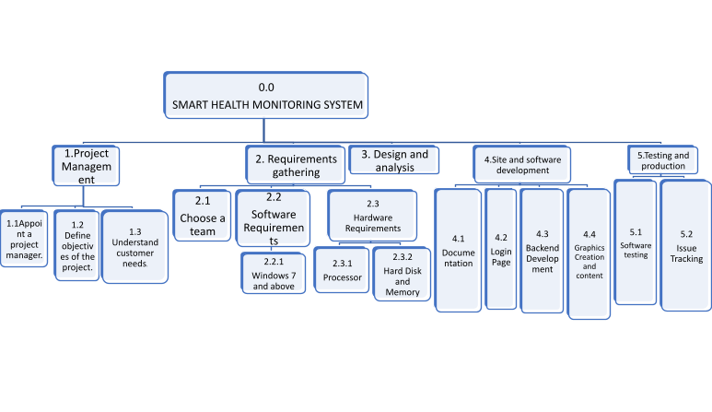 **1) WORK BREAKDOWN STRUCTURE :**

Figure 5.1

0.0 -SMART HEALTH MONITORING SYSTEM

* 1.Project Management
* 1.1 - Appoint a project manager.
* 1.2 - Define objectives of the project.
* 1.3 - Understand customer needs.
* 2. Requirements gathering
* 2.1 - Choose a team
* 2.2 - Software Requirements
* 2.2.1 -Windows 7 and above
* 2.3 - Hardware Requirements
* 2.3.1- Processor
* 2.3.2 -Hard Disk and Memory
* 3. Design and analysis
* 4.Site and software development
* 4.1 -Documentation
* 4.2 -Login Page
* 4.3- Backend Development
* 4.4 -Graphics Creation and content
* 5.Testing and production
* 5.1 -Software testing
* 5.2 - Issue Tracking

**2) TIMELINE – GANTT CHART**

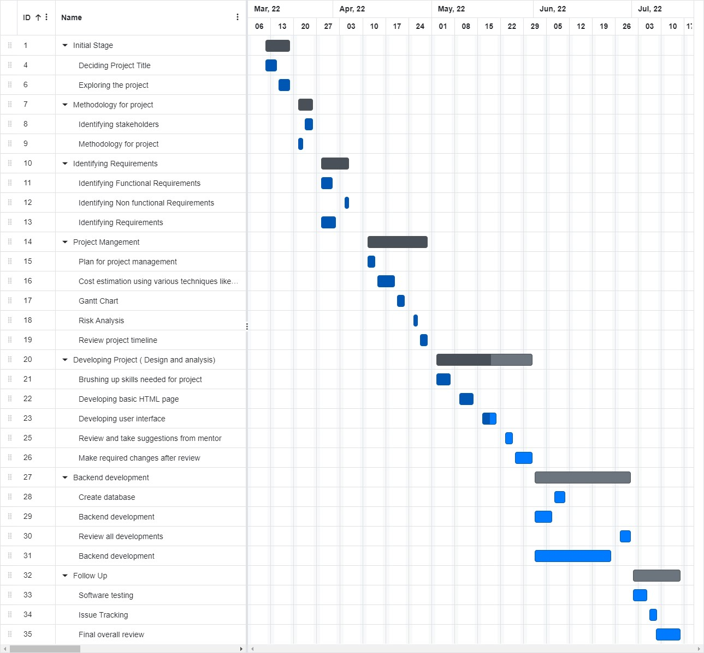

Figure 5.2

1. **RISK ANALYSIS – SWOT & RMMM:**

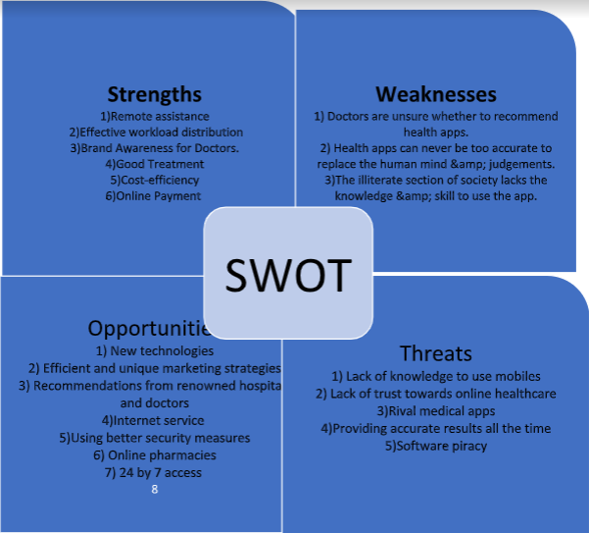Figure 5.3

**Result:**

Thus, the work breakdown structure with timeline chart and risk table were formulated successfully.

##### WBS – Examples

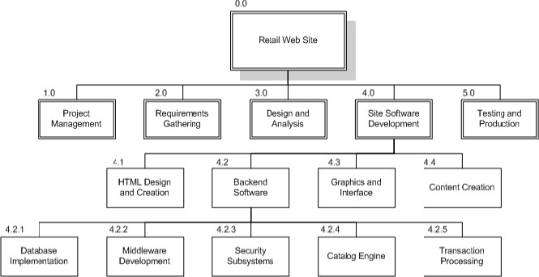

0.0 Retail Web Site

1.0 Project Management

2.0 Requirements Gathering

3.0 Analysis & Design

4.0 Site Software Development

◦ 4.1 HTML Design and Creation

◦ 4.2 Backend Software

* 4.2.1 Database Implementation
* 4.2.2 Middleware Development
* 4.2.3 Security Subsystems
* 4.2.4 Catalog Engine
* 4.2.5 Transaction Processing

◦ 4.3 Graphics and Interface

◦ 4.4 Content Creation 5.0 Testing and Production

##### TIMELINE – GANTT CHART

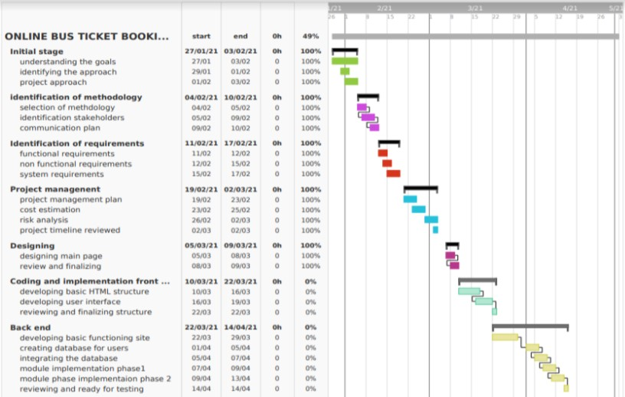

##### RISK ANALYSIS – SWOT & RMMM

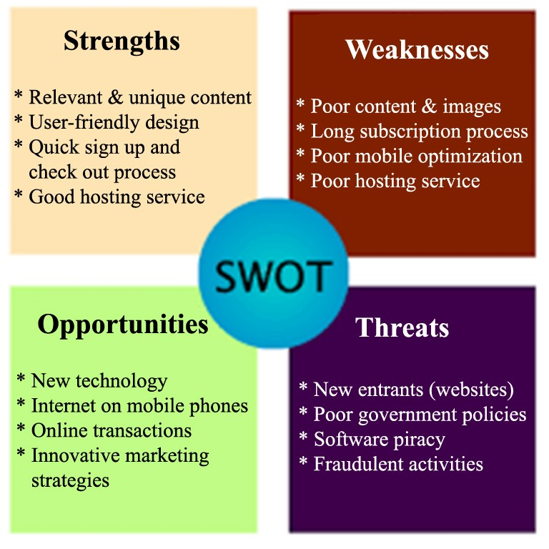

CHAPTER – 6

**Course Code: 18CSC206J**

**Course Name: Software Engineering and Project Management**

|  |  |
| --- | --- |
| **Experiment No** | 6 |
| **Title of Experiment** | System Architecture,Class Diagram, Usecase Diagram |
| **Name of the candidate** |  |
| **Team Members** | AADIT TRIVEDI, KRISHITAA BALAMURALI, PUTTA SRI NAGA SANJANA |
| **Register Number** |  |
| **Date of Experiment** | 21/04/22 |

##### Mark Split Up

|  |  |  |  |  |
| --- | --- | --- | --- | --- |
| **S.No** |  | **Description** | **Maximum Mark** | **Mark Obtained** |
| 1 | Exercise |  | 5 |  |
| 2 | Viva |  | 5 |  |
| **Total** | | | **10** |  |

#### 

**Team Members:**

|  |  |  |  |
| --- | --- | --- | --- |
| **Sl No** | **Register No** | **Name** | **Role** |
| **1** | **RA2011003010127** | **Aadit Trivedi** | **Rep** |
| **2** | **RA2011003010123** | **Putta Sri Naga Sanjana** | **Member** |
| **3** | **RA2011003010115** | **Krishitaa Balamurali** | **Member** |

##### Aim

To Prepare System Architecture,Class Diagram, Usecase Diagram

**Team Members:**

* SYSTEM ARCHITECTURE

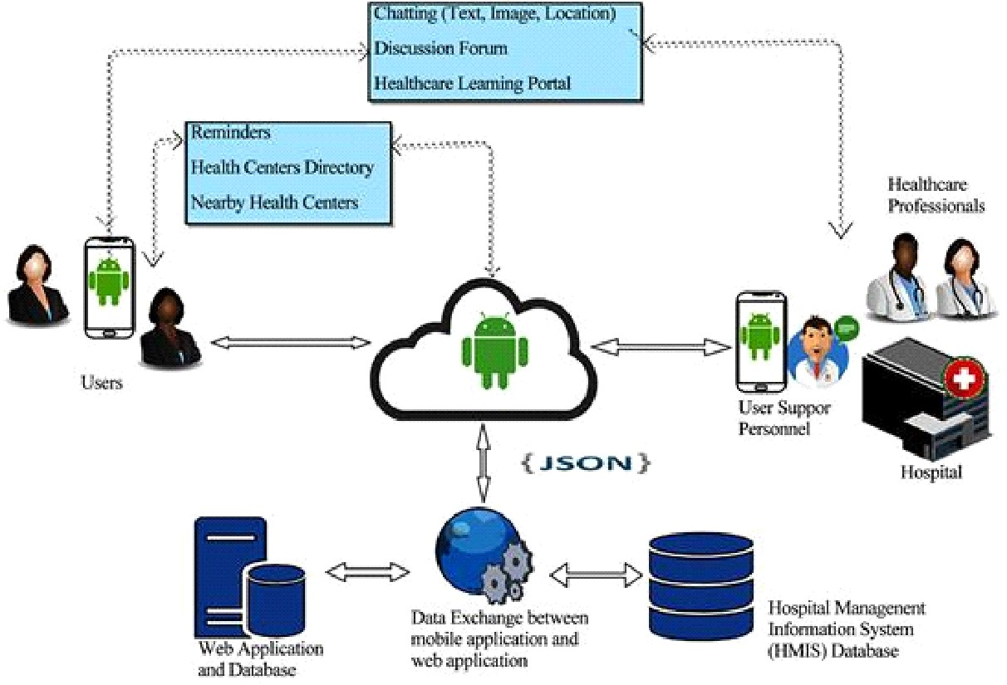

Figure 6.1

* CLASS DIAGRAM

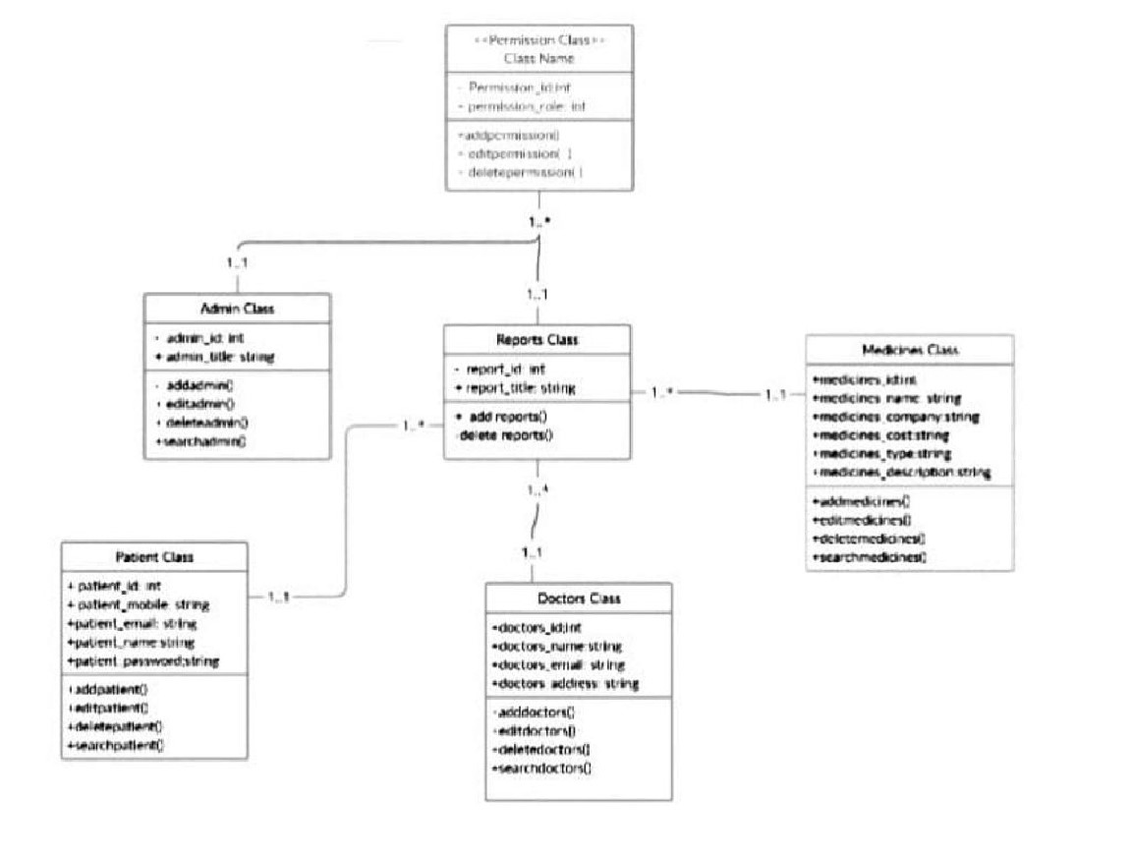

Figure 6.2

● USE CASE DIAGRAM

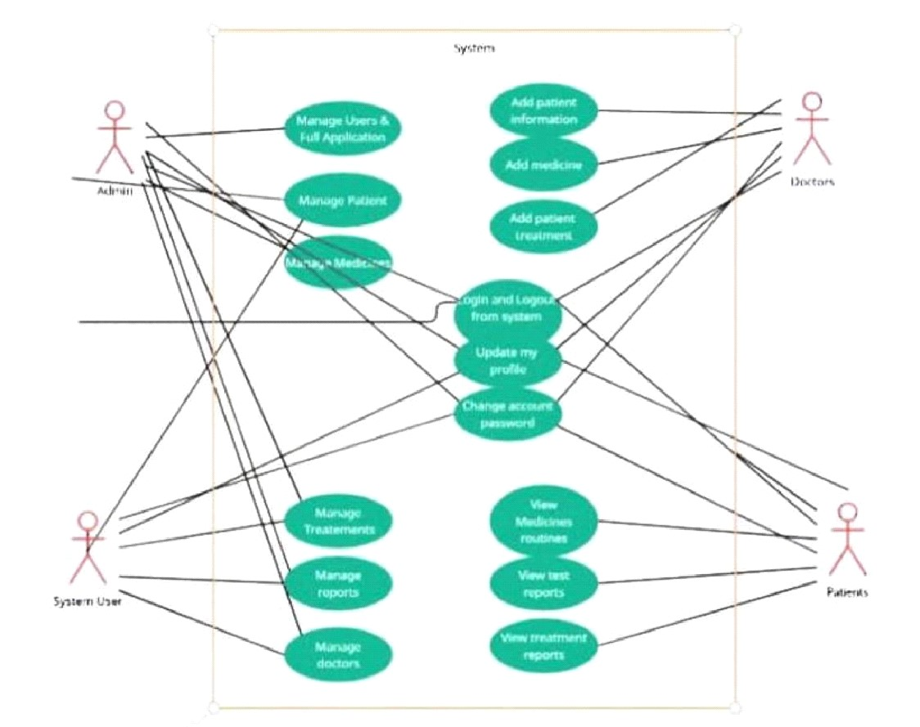

Figure 6.3

**Result:**

Thus ,the system architecture,use case diagram and class diagram created successfully.

CHAPTER – 7

**Course Code: 18CSC206J**

**Course Name: Software Engineering and Project Management**

|  |  |
| --- | --- |
| **Experiment No** | 7 |
| **Title of Experiment** | Design a Entity relationship diagram |
| **Name of the candidate** |  |
| **Team Members** | AADIT TRIVEDI, KRISHITAA BALAMURALI,  PUTTA SRI NAGA SANJANA |
| **Register Number** |  |
| **Date of Experiment** | 06/05/22 |

##### Mark Split Up

|  |  |  |  |  |  |
| --- | --- | --- | --- | --- | --- |
| **S. No** |  | **Description** |  | **Maximum Mark** | **Mark Obtained** |
| 1 | Exercise |  |  | 5 |  |
| 2 | Viva |  |  | 5 |  |
|  |  |  | **Total** | **10** |  |

**Team Members:**

|  |  |  |  |
| --- | --- | --- | --- |
| **S No** | **Register No** | **Name** | **Role** |
| **1** | **RA2011003010127** | **Aadit Trivedi** | **Rep** |
| **2** | **RA2011003010123** | **Putta Sri Naga Sanjana** | **Member** |
| **3** | **RA2011003010115** | **Krishitaa Balamurali** | **Member** |

##### Aim

To create the Entity Relationship Diagram

<ER Diagram >

TOPIC – A SMART HEALTH MONITORING SYSTEM

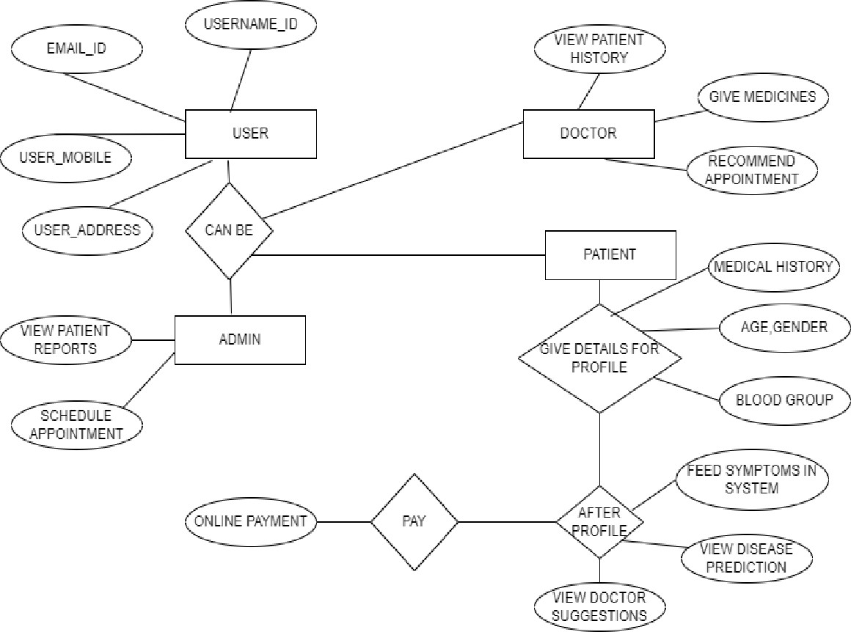

Figure 7.1

**Result:**

Thus, the entity relationship diagram was created successfully.

**\*/ ER Diagram, Notation and Example What is ER Diagram?**

* ER Diagram stands for Entity Relationship Diagram, also known as ERD is a diagram thatdisplays the relationship of entity sets stored in a database. In other words, ER diagrams help to explain the logical structure of databases. ER diagrams are created based on three basic concepts: entities, attributes and relationships.
* ER Diagrams contain different symbols that use rectangles to represent entities, ovals to defineattributes and diamond shapes to represent relationships.
* At first look, an ER diagram looks very similar to the flowchart. However, ER Diagramincludes many specialized symbols, and its meanings make this model unique. The purpose of ER Diagram is to represent the entity framework infrastructure.

**What is ER Model?**

* ER Model stands for Entity Relationship Model is a high-level conceptual data model diagram.ER model helps to systematically analyze data requirements to produce a well-designed database.
* ER Model represents real-world entities and the relationships between them. Creating an ERModel in DBMS is considered as a best practice before implementing your database.
* ER Modeling helps you to analyze data requirements systematically to produce a well-designeddatabase. So, it is considered a best practice to complete ER modeling before implementing your database.

**Why use ER Diagrams?**

Here, are prime reasons for using the ER Diagram

* Helps you to define terms related to entity relationship modeling
* Provide a preview of how all your tables should connect, what fields are going to be on eachtable
* Helps to describe entities, attributes, relationships
* ER diagrams are translatable into relational tables which allows you to build databases quickly- ER diagrams can be used by database designers as a blueprint for implementing data in specific software applications
* The database designer gains a better understanding of the information to be contained in thedatabase with the help of ERP diagram
* ERD Diagram allows you to communicate with the logical structure of the database to users

**Components of the ER Diagram**

This model is based on three basic concepts: Entities, Attributes, Relationships

##### ER Diagram – Notations

* Rectangles represent entity sets.
* Diamonds represent relationship sets.
* Lines link attributes to entity sets and entity sets to relationship sets.
* Ellipses represent attributes
* Double ellipses represent multivalued attributes.- Dashed ellipses denote derived attributes.
* Underline indicates primary key attributes

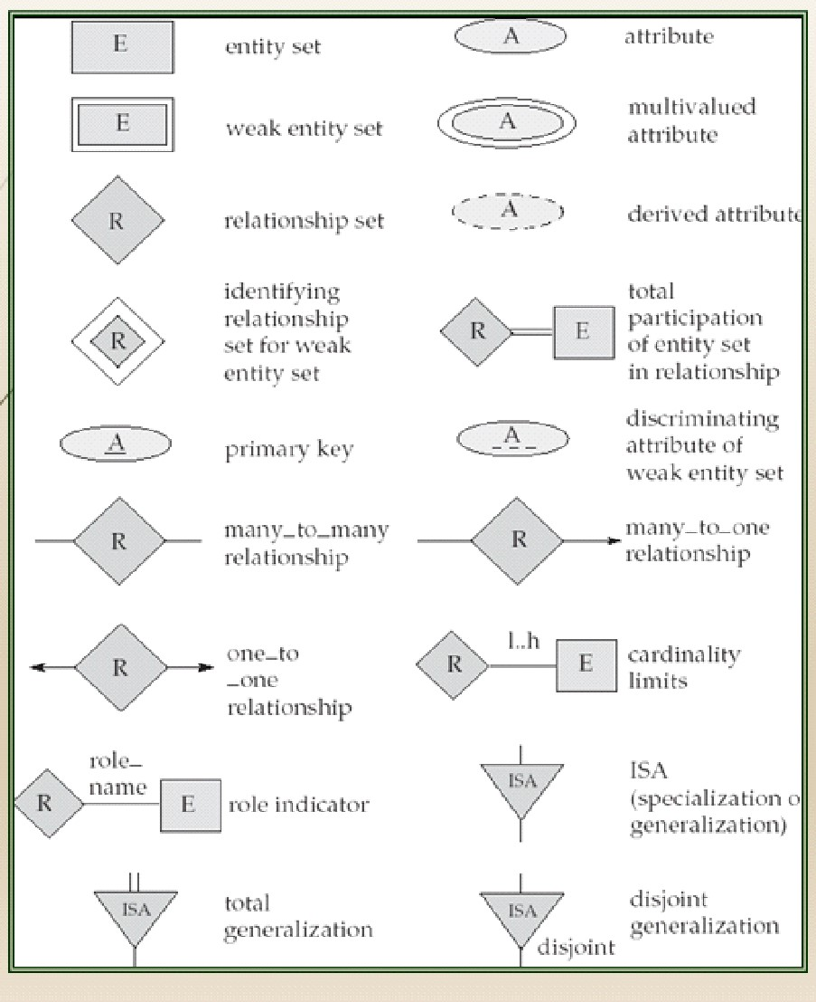

##### ER Diagram of University Database

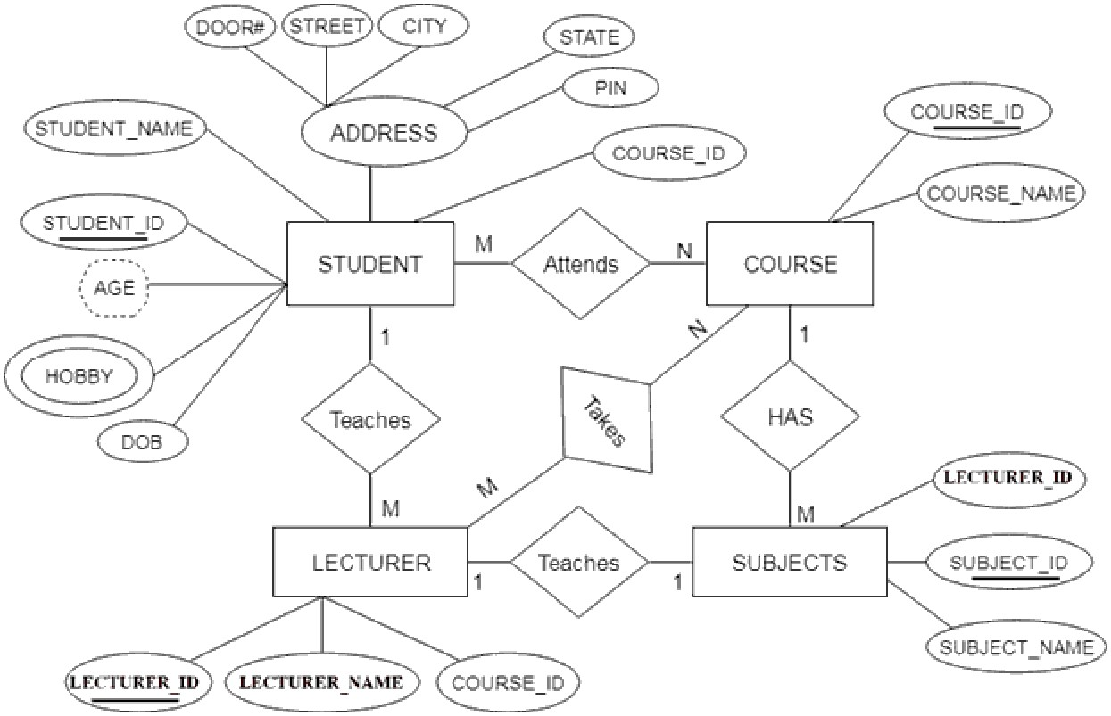

##### ADDITIONAL NOTES

* A database can be modeled as a collection of entities, relationship among entities.
* An entity is an object that exists and is distinguishable from other objects.Example: specific person, company, event, plant - Entities have attributes.

Example: people have names and addresses

* An entity set is a set of entities of the same type that share the same properties.Example: set of all persons, companies, trees, holidays
* Express the number of entities to which another entity can be associated via a relationship set.
* Most useful in describing binary relationship sets.
* We express cardinality constraints by drawing either a directed line (->), signifying “one,” or an undirected line (—), signifying “many,” between the relationship set and the entity set.
* An entity is represented by a set of attributes, that is descriptive properties possessed by all members of an entity set.

Example: customer = (customer-id, customer-name, customer-street, customer-city) loan = (loan-number, amount)

* Domain – the set of permitted values for each attribute- Attribute types:

1. Simple and composite attributes.
2. Single-valued and multi-valued attributes

E.g. multivalued attribute: phone-numbers

1. Derived attributes-Can be computed from other attributes

E.g. age, given date of birth

###### Cardinality

- For a binary relationship set the mapping cardinality must be one of the following types:

1. One to one

A customer is associated with at most one loan via the relationship borrower. A loan is associated with at most one customer via borrower

2. One to many

A loan is associated with at most one customer via borrower, a customer is associated with several (including 0) loans via borrower

3. Many to one

A loan is associated with several (including 0) customers via borrower, a customer is associated with at most one loan via borrower

4. Many to many

A loan is associated with several (including 0) customers via borrower, a customer is associated with several loans (including 0) via borrower

###### Weak Entity Set

- An entity set that does not have a primary key is referred to as a weak entity set and represented by double outlined box in E-R diagram.

Example : Consider the entity set payment which got three attributes : payment_number, payment_date and payment_amount. Payment numbers are sequential starting from 1 generally separately for each loan. Although each payment entity is distinct, payments for different loans may share the same payment number. Thus this entity set does not have a primary key.

###### Discriminator

- The discriminator (or partial key) of a weak entity set is the set of attributes that distinguishes among all the entities of a weak entity set

Example: discriminator of weak entity set payment is the attribute payment_number since for each loan a payment number uniquely identifies one single payment for that loan.

###### Specialization-Generalization-ISA

* E-R model provides means of representing these distinctive entity groupings
* Process of designating subgroupings within an entity set is called specialization depicted by triangle component labelled ISA (“is a”)
* Bottom up design process in which multiple entity sets are synthesized into higher level entity set - Generalization
* ISA relationship may also be referred to as superclass-subclass relationship
* Higher and lower level entity sets are designated by the terms superclass and subclass.- Specialization and generalization are simple inversions of each other; they are represented in an E-R diagram in the same way.

###### Total & Partial Participation

* Total participation (indicated by double line): every entity in the entity set participates in at least one relationship in the relationship set

E.g. participation of loan in borrower is total, every loan must have a customer associated to it via borrower

* Partial participation: some entities may not participate in any relationship in the relationship set

Example: participation of customer in borrower is partial

###### Cardinality limits

* Cardinality limits can also express participation constraints
* Minimum and maximum cardinality is expressed as l..h where l is the minimum and h is the maximum cardinality
* Minimum value of 1 indicates total participation of entity set in relationship set- Maximum value of 1 indicates entity participates in atmost one relationship set. - Maximum value of * indicates no limit

###### Role indicator

* Entity sets of a relationship need not be distinct
* The labels “manager” and “worker” are called roles; they specify how employee entities interact via the works-for relationship set.
* Roles are indicated in E-R diagrams by labeling the lines that connect diamonds to rectangles.- Role labels are optional, and are used to clarify semantics of the relationship

###### Disjoint Generalization

- Disjointness constraint requires that an entity belong to more than one lower level entity set.

Example: account entity can satisfy only one condition for account_type attribute ; entity can either be savings or chequing account but not both.

CHAPTER – 8

**Course Code: 18CSC206J**

**Course Name: Software Engineering and Project Management**

|  |  |
| --- | --- |
| **Experiment No** | 8 |
| **Title of Experiment** | Develop a Data Flow Diagram (Process-Up to Level 1) |
| **Name of the candidate** |  |
| **Team Members** | AADIT TRIVEDI, KRISHITAA BALAMURALI, PUTTA SRI NAGA SANJANA |
| **Register Number** |  |
| **Date of Experiment** | 13/05/2022 |

##### Mark Split Up

|  |  |  |  |  |
| --- | --- | --- | --- | --- |
| **S. No** |  | **Description** | **Maximum Mark** | **Mark Obtained** |
| 1 | Exercise |  | 5 |  |
| 2 | Viva |  | 5 |  |
| **Total** | | | **10** |  |

|  |  |  |  |
| --- | --- | --- | --- |
| **S No** | **Register No** | **Name** | **Role** |
| **1** | **RA2011003010127** | **Aadit Trivedi** | **Rep** |
| **2** | **RA2011003010123** | **Putta Sri Naga Sanjana** | **Member** |
| **3** | **RA2011003010115** | **Krishitaa Balamurali** | **Member** |

**Team Members:**

##### Aim

To develop the data flow diagram up to level 1 for the <project name>

##### <DFD >

**LEVEL 0:**

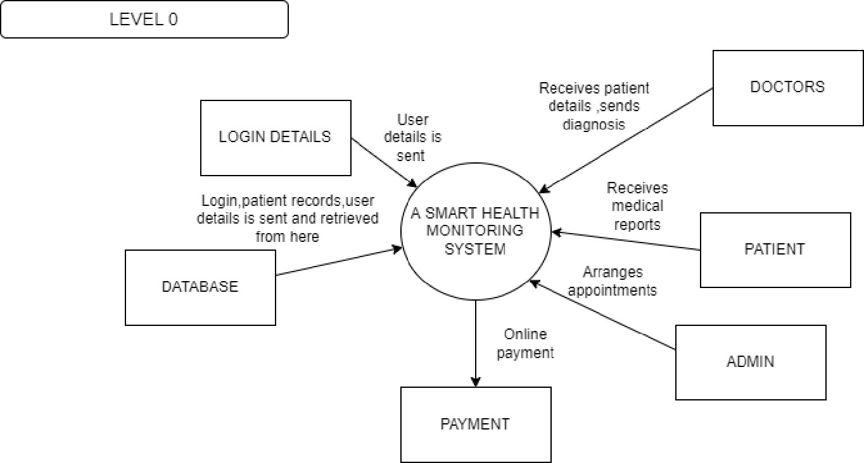

Figure 8.1

**LEVEL 1:**

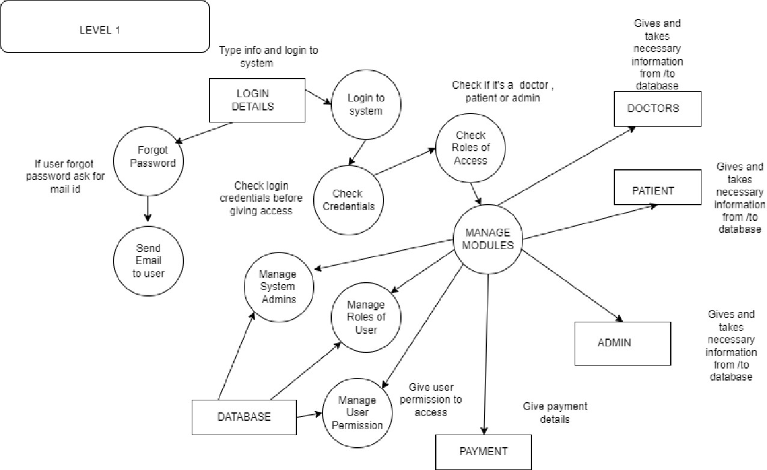

Figure 8.2

**LEVEL 2:**

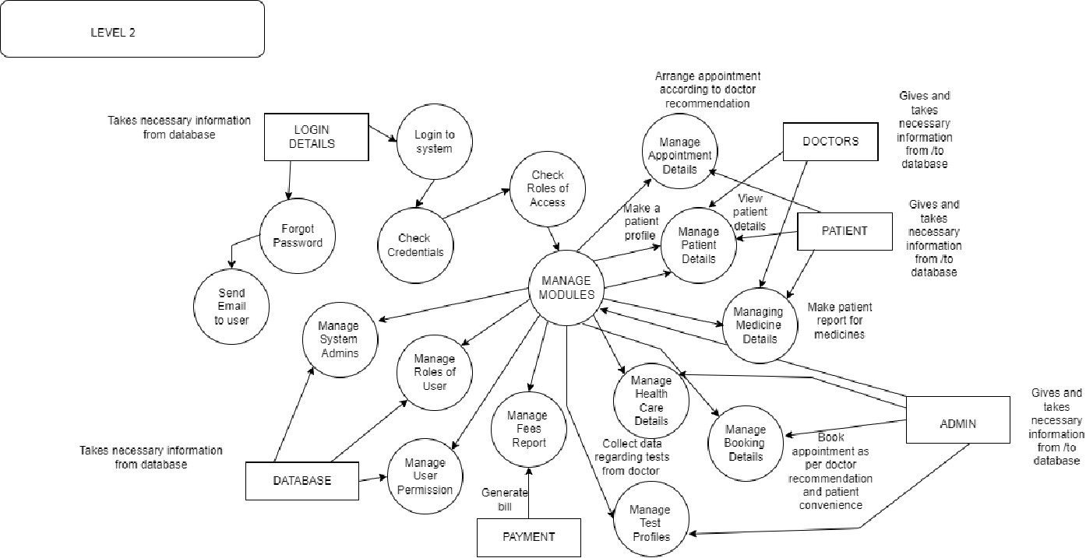

Figure 8.3

**Result:** Thus, the data flow diagrams have been created for the smart health monitoring system.

###### Data Flow Diagram

The DFD takes an input-process-output view of a system. That is, data objects flow into the software, are transformed by processing elements, and resultant data objects flow out of the software. Data objects are represented by labeled arrows, and transformations are represented by circles (also called bubbles). The DFD is presented in a hierarchical fashion. That is, the first data flow model (sometimes called a level 0 DFD or context diagram) represents the system as a whole. Subsequent data flow diagrams refine the context diagram, providing increasing detail with each subsequent level.

The data flow diagram enables you to develop models of the information domain and functional domain. As the DFD is refined into greater levels of detail, you perform an implicit functional decomposition of the system. At the same time, the DFD refinement results in a corresponding refinement of data as it moves through the processes that embody the application.

A few simple guidelines can aid immeasurably during the derivation of a data flow diagram:

1. Level 0 data flow diagram should depict the software/system as asingle bubble;
2. Primary input and output should be carefully noted;
3. Refinement should begin by isolating candidate processes, data objects, and data stores to be

represented at the next level;

1. All arrows and bubbles should be labeled with meaningful names;
2. Information flow continuity must be maintained from level to level and
3. One bubble at a time should be refined. There is a natural tendency to overcomplicate the data flow diagram. This occurs when you attempt to show too much detail too early or represent procedural aspects of the software in lieu of information flow.

###### */ For Example

DFD Level 0

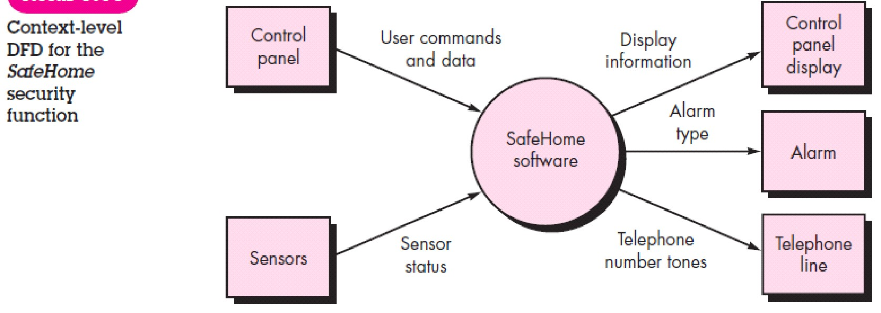

DFD Level 1

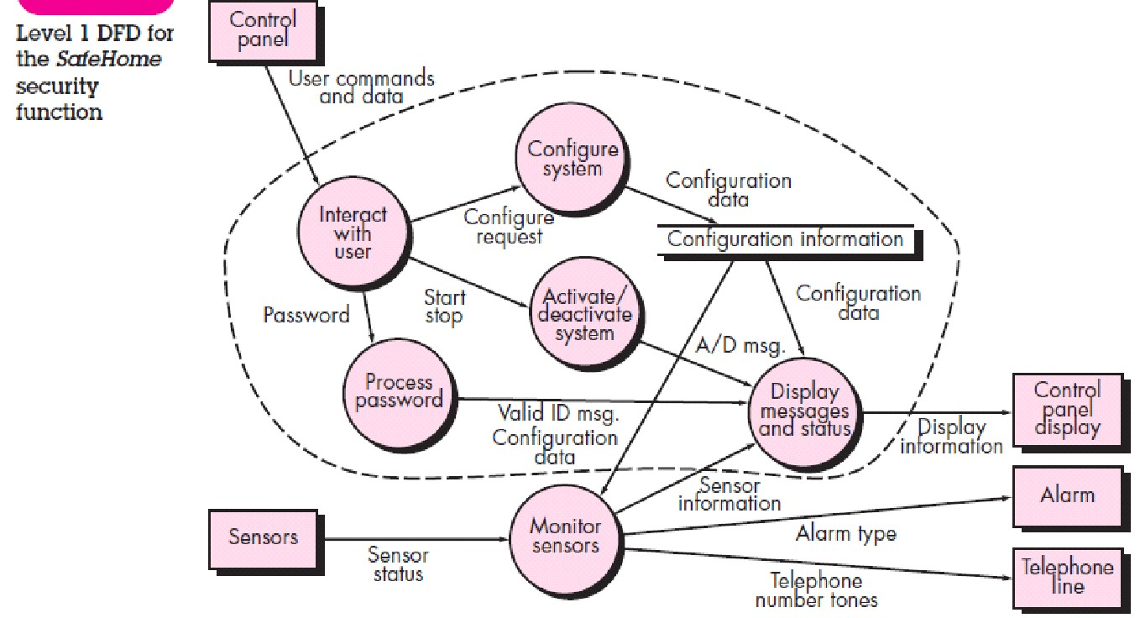

CHAPTER – 9

**Course Name: Software Engineering and Project Management**

**Course Code: 18CSC206J**

|  |  |
| --- | --- |
| **Experiment No** | 9 |
| **Title of Experiment** | Design a Sequence and Collaboration Diagram |
| **Name of the candidate** |  |
| **Team Members** | AADIT TRIVEDI, KRISHITAA BALAMURALI, PUTTA SRI  NAGA SANJANA |
| **Register Number** |  |
| **Date of Experiment** | 20/05/22 |

##### Mark Split Up

|  |  |  |  |  |  |
| --- | --- | --- | --- | --- | --- |
| **S. No** |  | **Description** |  | **Maximum Mark** | **Mark Obtained** |
| 1 | Exercise |  |  | 5 |  |
| 2 | Viva |  |  | 5 |  |
|  |  |  | **Total** | **10** |  |

**Team Members:**

|  |  |  |  |
| --- | --- | --- | --- |
| **S No** | **Register No** | **Name** | **Role** |
| **1** | **RA2011003010127** | **Aadit Trivedi** | **Rep/Member** |
| **2** | **RA2011003010123** | **Putta Sri Naga Sanjana** | **Member** |
| **3** | **RA2011003010115** | **Krishitaa Balamurali** | **Member** |

**Aim**

To create the sequence and collaboration diagram for the SMART HEALTH MONITORING SYSTEM

<Sequence and Collaboration Diagram>

**Sequence diagram:**

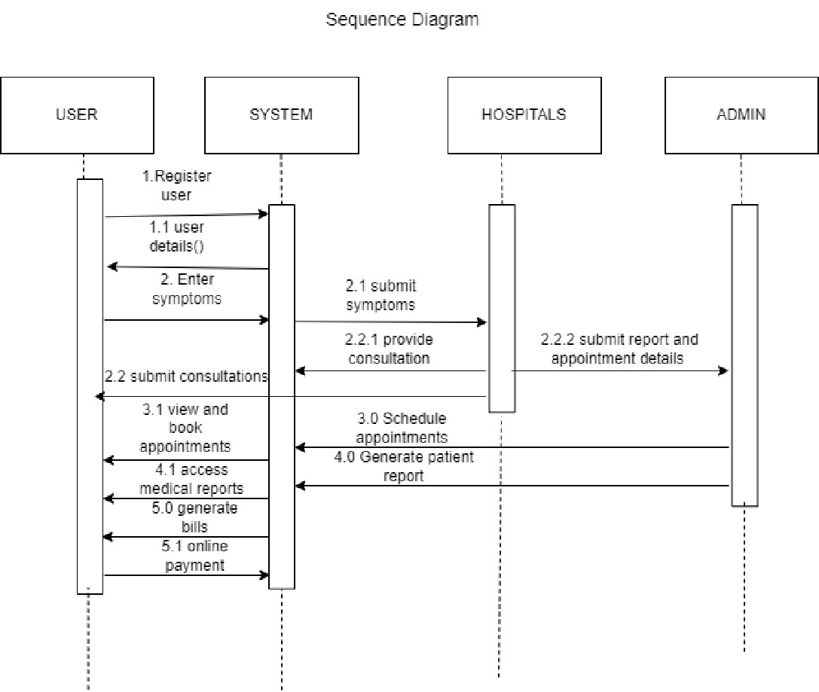

Figure 9.1

**Collaboration diagram :**

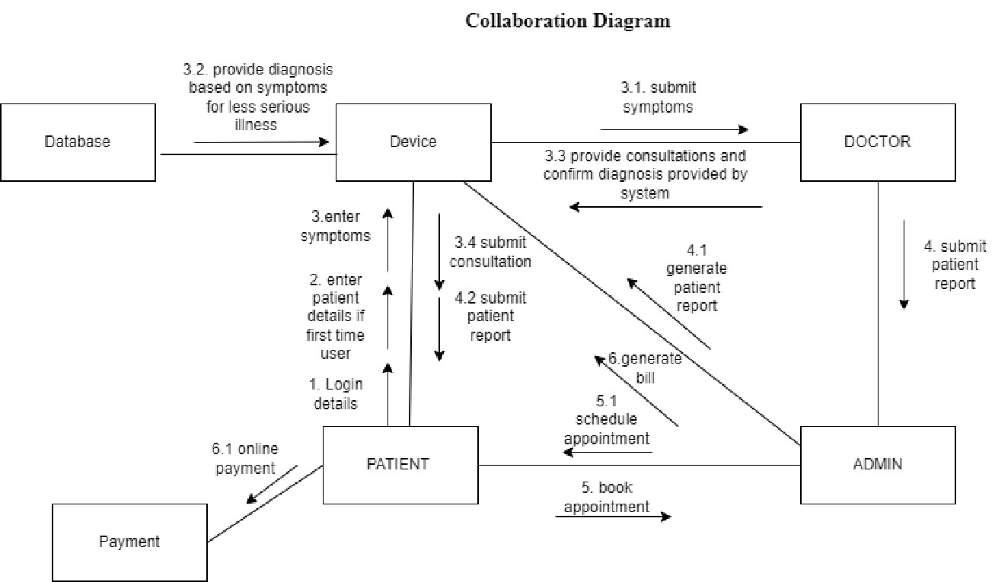

Figure 9.2

**Result:**

Thus, the sequence and collaboration diagrams were created for the <project> online health monitoring sytsem.

**\*/ For Example**

**Sequence Diagram**

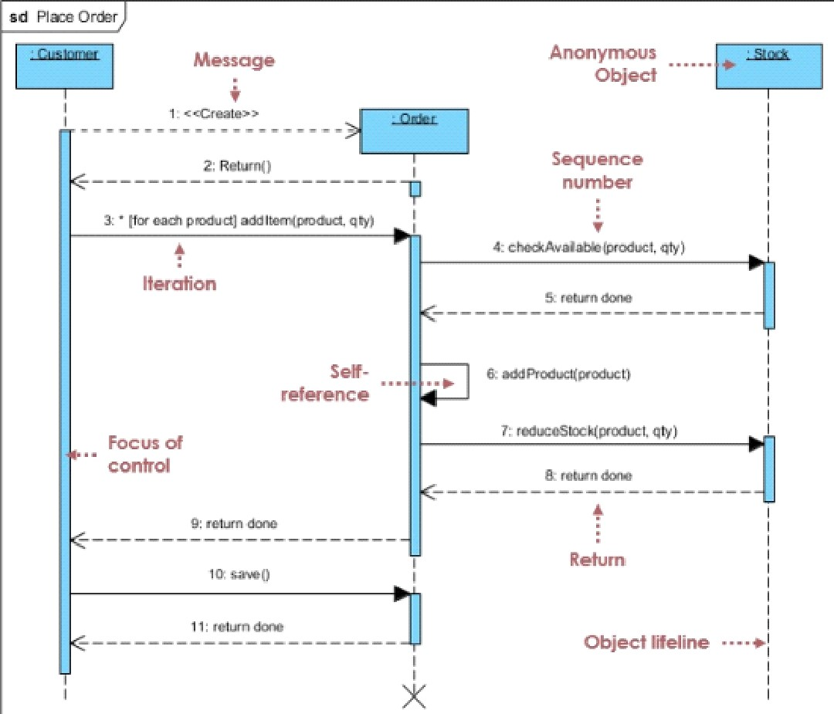

**Collaboration Diagram**

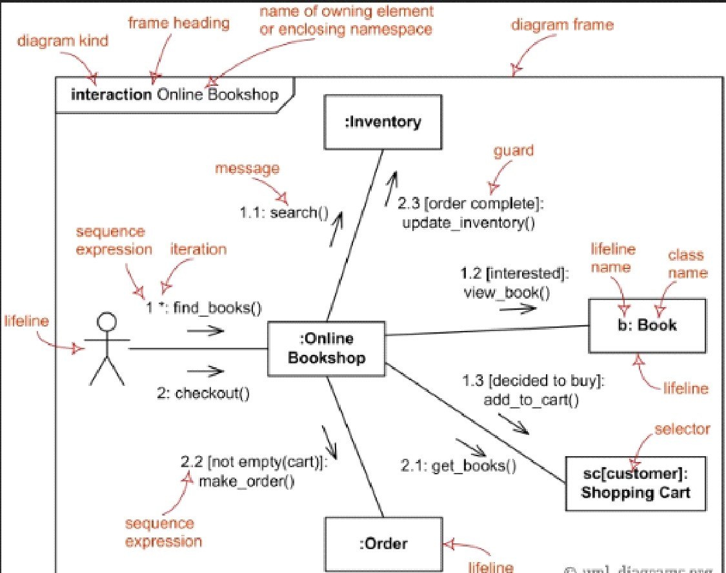

CHAPTER – 10

**Course Code: 18CSC206J**

**Course Name: Software Engineering and Project Management**

|  |  |
| --- | --- |
| Experiment No | 10 |
| Title of Experiment | Develop a Testing Framework/User Interface |
| Name of the candidate |  |
| Team Members | AADIT TRIVEDI, KRISHITAA BALAMURALI, PUTTA SRI  NAGA SANJANA |
| Register Number |  |
| Date of Experiment | 27/05/22 |

**Mark Split Up**

|  |  |  |  |  |  |
| --- | --- | --- | --- | --- | --- |
| S. No |  | Description |  | Maximum Mark | Mark Obtained |
| 1 | Exercise |  |  | 5 |  |
| 2 | Viva |  |  | 5 |  |
|  |  |  | Total | 10 |  |

**Team Members:**

|  |  |  |  |
| --- | --- | --- | --- |
| S No | Register No | Name | Role |
| 1 | AADIT TRIVEDI | RA2011003010127 | Rep/Member |
| 2 | PUTTA SRI NAGA SANJANA | RA2011003010123 | Member |
| 3 | KRISHITAA BALAMURALI | RA2011003010115 | Member |

Aim

To develop the testing framework and/or user interface framework for the Liber

# Executive Summary

The scope of a test defines what areas of a customer's product are supposed to get tested. The scope of testing of our software application is to check functional requirements like login, searching and fetching and non-functional requirements like speed and performance.

The objective of testing our software is to :

1)identify bugs and solve them

2) improve performance and speed

3)fulfill various functional and non- functional requirements.

1. To make sure that the end result meets the user requirements.
2. To design effective test cases for identifying the errors.

The approach to test the software application is manual using word template and checking for each sample test case and maintain a test manual and check for expected and actual outcome.

# Test Plan

|  |  |  |
| --- | --- | --- |
| **Duration** | **Subject** | **Methodology** |
| 2 -3 weeks | Functional Requirements  (Login, Details Display,  Details Editing, Medical  Records Display, payment details, appointment details) | Manual Testing- Acceptance Testing |
| • 2 weeks | Non-Functional  Requirements (Speed,  Usability, Effectiveness) | Manual Testing-  Compatibility, Performance,  Usability Testing |

# Test Plan Scope of Testing

The testing will cover testing the home page and post page and testing for valid string query in search bar and testing various non-functional requirements like speed, performance, delay.

* Functional: All functional requirement are being taken cared of. For eg:- Allow the user to search for doctor on their requirement, medical record, appointment details, online payment Check id details can be easily updated and displayed,etc.

.,

* Non-Functional: Almost all non- functional requirement are being taken cared of. For eg:Performance, Speed, Time delay, huge traffic of usersCheck if functionalities are timely executed.

.

# Types of Testing, Methodology, Tools

|  |  |  |
| --- | --- | --- |
| Category | Methodology | Tools Required |
| Functional  Requirements | Manual | Word Template |
| Non-Functional Requirements | Manual | Word Template |

**Result:**

Thus, the testing framework/user interface framework has been created for the project.

`

CHAPTER – 11

**Course Code: 18CSC206J**

**Course Name: Software Engineering and Project Management**

|  |  |
| --- | --- |
| **Experiment No** | 11 |
| **Title of Experiment** | Test Cases |
| **Name of the candidate** |  |
| **Team Members** | Aadit Trivedi, Krishitaa Balamurali, Putta Sri Naga Sanjana |
| **Register Number** |  |
| **Date of Experiment** | 11/06/2022 |

**Mark Split Up**

|  |  |  |  |
| --- | --- | --- | --- |
| **S. No** | **Description** | **Maximum Mark** | **Mark Obtained** |
| 1 | Exercise | 5 |  |
| 2 | Viva | 5 |  |
| **Total** | | **10** |  |

**Team Members:**

|  |  |  |  |
| --- | --- | --- | --- |
| **S. No** | **Register No** | **Name** | **Role** |
| **1** | **RA2011003010127** | **Aadit Trivedi** | **Lead/Rep** |
| **2** | **RA2011003010115** | **Krishitaa Balamurali** | **Member** |
| **3** | **RA2011003010123** | **Putta Sri Naga Sanjana** | **Member** |

**Aim**

To develop the test cases manual for the SMART HEALTH MANAGEMENT SYSTEM.

# 

**Functional Test Cases**

|  |  |  |  |  |  |  |  |
| --- | --- | --- | --- | --- | --- | --- | --- |
| **Test ID (#)** | **Test**  **Scenario** | **Test Case** | **Execution Steps** | **Expected Outcome** | **Actual Outcome** | **Status** | **Remarks** |
| FR1 | Verify  User  Login | To check if Login is authenticated correctly. | Start the S/W. Enter Login  Credentials. | Login Valid/Invalid according to input and details  display or home screen. | Login Valid according to valid inputs and appropriate  message  for invalid input. | Pass | Success |
| FR2 | Forgot password | To generate a mail if user clicks on forgot password. | Start the S/W. Enter Login  Credentials. | Details displayed successfully. | Details displayed successfully. | Pass | Success |
| FR3 | User Details display. | To check if  S/W can Display details correctly. | Start the S/W. Enter Login Credentials.  Check details. | Details displayed successfully. | Details displayed successfully. | Pass | Success |
| FR4 | Login access | To check if S/W can find whether user is doctor ,patient or admin correctly. | Start the S/W. Enter Login Credentials.  Check details as per credentials | Details displayed successfully. | Details displayed successfully. | Pass | Success |
| FR5 | Enter symptoms | To check if  S/W can  Predict disease based on symptoms correctly. | Start the S/W. Enter Login Credentials. Enter symptoms.  Check details | Details displayed successfully. | Details displayed successfully. | Pass | Success |
| FR6 | Medical Report details | To check if  S/W can  Display  Medical Report details correctly. | Start the S/W. Enter Login Credentials. Check Medical Report details. | Medical Report details displayed successfully. | Medical Report details displayed successfully. | Pass | Success |
| FR7 | Medicine details | To check if  S/W can  Display  Medicine details correctly. | Start the S/W. Enter Login Credentials. Check Medicine Report details. | Medicine Report details displayed successfully. | Medicine Report details displayed successfully. | Pass | Success |
| FR8 | Schedule appointment  (Fix appointment as per patient and doctor recommendation) | To check if  S/W can  Display  Booking of  appointment details correctly. | Start the S/W. Enter Login Credentials. Check booking of appointment related details. | Scheduling details displayed successfully | Scheduling details displayed successfully | Pass | Success |
| FR9 | Appointment details Display | To check if  S/W can  Display  Appointment  details correctly. | Start the S/W. Enter Login Credentials. Check Appointment details | Appointment details displayed successfully. | Appointment details displayed successfully. | Pass | Success |
| FR10 | Online payment | To check if S/W can  Payment details are displayed correctly. | Start the S/W. Enter Login  Credentials. Follow the details for payment . | Payment done successfully. | Payment done successfully. | Pass | Success |

**Non-Functional Test Cases**

|  |  |  |  |  |  |  |  |
| --- | --- | --- | --- | --- | --- | --- | --- |
| **Test ID (#)** | **Test**  **Scenario** | **Test Case** | **Execution**  **Steps** | **Expected Outcome** | **Actual Outcome** | **Status** | **Remarks** |
| NFR1 | Usability | To check if UI is  usable by  generic users | Start the S/W.  Check inputs and usability. | Easy to use. | Good usability. | Pass | Success |
| NFR2 | Acceptance | To check if system  is accepting details | Start the S/W.  Check acceptance by entering details and waiting for it to display. | Good acceptance rate. | Good acceptance rate. | Pass | Success |
| NFR3 | Speed of response | To check that  the  S/W can be  fast to respond to querie  s | Start the S/W. Check any functionalities and time the response. | Fast in response. | Fast response recorded. | Pass | Success |
| NFR4 | Input response | To check that the system can respond to various inputs | Start the S/W. Check any input including valid and invalid. | Can respond to valid/invalid inputs. | Valid response to inputs. | Pass | Success *A more user friendly message to be displayed in case of invalid input. |

**Result:**

Thus, the test case manual has been created for the SMART HEALTH MONITORING SYSTEM.

CHAPTER – 12

**Course Name: Software Engineering and Project Management**

**Course Code: 18CSC206J**

|  |  |
| --- | --- |
| **Experiment No** | 12 |
| **Title of Experiment** | Manual Test Case Reporting |
| **Name of the candidate** |  |
| **Team Members** | Aadit Trivedi, Krishitaa Balamurali, Putta Sri Naga Sanjana |
| **Register Number** |  |
| **Date of Experiment** | **11/06/22** |

### Mark Split Up

|  |  |  |  |  |  |
| --- | --- | --- | --- | --- | --- |
| **S. No** |  | **Description** |  | **Maximum Mark** | **Mark Obtained** |
| 1 | Exercise |  |  | 5 |  |
| 2 | Viva |  |  | 5 |  |
|  | |  | **Total** | **10** |  |

**Team Members:**

|  |  |  |  |
| --- | --- | --- | --- |
| **S No** | **Register No** | **Name** | **Role** |
| **1** | RA2011003010127 | Aadit Trivedi | **Rep/Member** |
| **2** | RA2011003010123 | Putta Sri Naga Sanjana | **Member** |
| **3** | RA2011003010115 | Krishitaa Balamurali | **Member** |

### Aim

To prepare the manual test case report for the SMART HEALTH MONITORING SYSTEM.

**Functional Test Cases**

|  |  |  |  |  |  |  |  |
| --- | --- | --- | --- | --- | --- | --- | --- |
| **Test**  **ID**  **(#)** | **Test**  **Scenario** | **Test Case** | **Execution**  **Steps** | **Expected**  **Outcome** | **Actual**  **Outcome** | **Status** | **Remarks** |
| FR1 | Verify  User  Login | To check if Login is  authenticated correctly. | Start the  S/W. Enter Login  Credentials. | Login  Valid/Invalid according to input and details display or home screen. | Login Valid according to  valid inputs and  appropriate  message  for invalid input. | Pass | Success |

|  |  |  |  |  |  |  |  |
| --- | --- | --- | --- | --- | --- | --- | --- |
| FR2 | Forgot password | To generate a mail if user clicks on  forgot password. | Start the  S/W. Enter Login  Credentials. | Details displayed successfully. | Details displayed successfully. | Pass | Success |
| FR3 | User Details display. | To check if  S/W can Display details correctly. | Start the  S/W. Enter Login  Credentials. Check  details. | Details displayed successfully. | Details displayed successfully. | Pass | Success |
| FR4 | Login access | To check if S/W can find whether user is doctor ,patient or  admin correctly. | Start the  S/W. Enter Login  Credentials. Check details as per credentials | Details displayed successfully. | Details displayed successfully. | Pass | Success |
| FR5 | Enter symptoms | To check if  S/W can Predict  disease based on symptoms correctly. | Start the  S/W. Enter Login  Credentials. Enter symptoms.  Check details | Details displayed successfully. | Details displayed successfully. | Pass | Success |
| FR6 | Medical Report details | To check if  S/W can  Display  Medical  Report details correctly. | Start the  S/W. Enter Login  Credentials.  Check  Medical Report  details. | Medical Report details displayed successfully. | Medical Report details displayed successfully. | Pass | Success |
| FR7 | Medicine details | To check if  S/W can  Display Medicine  details correctly. | Start the  S/W. Enter Login  Credentials.  Check  Medicine Report  details. | Medicine Report details displayed successfully. | Medicine Report details displayed successfully. | Pass | Success |
| FR8 | Schedule appointment  (Fix appointment as per patient and doctor recommendation) | To check if  S/W can  Display Booking of appointment details correctly. | Start the  S/W. Enter Login  Credentials.  Check booking of appointment related details. | Scheduling details displayed successfully | Scheduling details displayed successfully | Pass | Success |
| FR9 | Appointment details Display | To check if  S/W can  Display Appointment  details correctly. | Start the  S/W. Enter Login  Credentials.  Check  Appointment  details | Appointment  details displayed successfully. | Appointment  details displayed successfully. | Pass | Success |
| FR10 | Online payment | To check if  S/W can Payment  details are displayed correctly. | Start the  S/W. Enter Login  Credentials. Follow the details for payment . | Payment done successfully. | Payment done successfully. | Pass | Success |

**Non-Functional Test Cases**

|  |  |  |  |  |  |  |  |
| --- | --- | --- | --- | --- | --- | --- | --- |
| **Test**  **ID**  **(#)** | **Test**  **Scenario** | **Test**  **Case** | **Execution**  **Steps** | **Expected**  **Outcome** | **Actual**  **Outcome** | **Status** | **Remark**  **s** |
| NFR1 | Usability | To check  if UI is usable by generic users | Start the S/W. Check inputs and usability. | Easy to use. | Good usability. | Pass | Success |

|  |  |  |  |  |  |  |  |  |  |  |  |  |
| --- | --- | --- | --- | --- | --- | --- | --- | --- | --- | --- | --- | --- |
| NFR2 | Acceptanc e | To check if system is acceptin g details | | | Start the S/W.  Check acceptance by entering details and waiting for it to display. | | Good  acceptance rate. | Good  acceptanc e rate. | | Pass | Success | |
| NFR3 | Speed of response | To check that  the  S/W can be  fast to  respond to querie s | | | Start the S/W. Check any  functionalitie s and time the response. | | Fast in response. | Fast response recorded. | | Pass | Success | |
| NFR4 | Input response | To check that the system can respond to various inputs | | | Start the S/W. Check any input including valid and invalid. | | Can respond to  valid/invalid inputs. | Valid response to inputs. | | Pass | Success *A more user friendly message to be displayed in case of invalid input. | |
| **Category** | | | | **Progress Against Plan** | | | | **Status** | | | |
| Functional Testing | | | | Green | | | | Completed | | | |
| Non-Functional Testing | | | | Green | | | | Completed | | | |
| **Functional** | | | **Test Case Coverage (%)** | | | **Status** | | |
| Login | | | 10% | | | Completed | | |
| Forgot password | | | 10% | | | Completed | | |
| User Details | | | 30% | | | Completed | | |
| Login access | | | 10% | | | Completed | | |
| Enter symptoms | | | 30% | | | Completed | | |
| Medical Report details | | | 30% | | | Completed | | |
| Medicine details | | | 30% | | | Completed | | |
| Appointment details | | | 20% | | | Completed | | |
| Schedule appointment | | | 20% | | | Completed | | |
| Online payment | | | 30% | | | Completed | | |
| **Non-Functional** | | | **Test Case Coverage (%)** | | | **Status** | | |
| Usability | | | 30% | | | Completed | | |
| Acceptance | | | 40% | | | Completed | | |
| Speed | | | 10% | | | Completed | | |
| Response to various inputs | | | 20% | | | Completed | | |

**Result:**

Thus, the test case report has been created for SMART HEALTH MONITORING SYSTEM.

CHAPTER – 13

**Course Code: 18CSC206J**

**Course Name: Software Engineering and Project Management**

|  |  |
| --- | --- |
| **Experiment No** | 13 |
| **Title of Experiment** | Provide the details of Architecture  Design/Framework/Implementation |
| **Name of the candidate** |  |
| **Team Members** | KRISHITAA BALAMURALI, PUTTA SRI NAGA  SANJANA, AADIT TRIVEDI |
| **Register Number** |  |
| **Date of Experiment** | 17/06/2022 |

### Mark Split Up

|  |  |  |  |
| --- | --- | --- | --- |
| **S. No** | **Description** | **Maximum Mark** | **Mark Obtained** |
| 1 | Exercise | 5 |  |
| 2 | Viva | 5 |  |
|  |  | **Total 10** |  |

**Team Members:**

|  |  |  |  |
| --- | --- | --- | --- |
| **S No** | **Register No** | **Name** | **Role** |
| **1** | **RA2011003010127** | **AADIT TRIVEDI** | **Rep/Member** |
| **2** | **RA2011003010115** | **KRISHITAA BALAMURALI** | **Member** |
| **3** | **RA2011003010123** | **PUTTA SRI NAGA SANJANA** | **Member** |

**Aim**

To provide the details of architectural design/framework/implementation

Website architecture is the hierarchical structure of website pages. This structure is reflected through internal linking. Website’s structure should help users easily find information and help search engine crawlers understand the relationship between different pages.

**USER PAGE:**

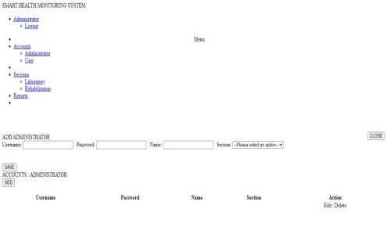

**USER PAGE CODE:**

<!DOCTYPE html>

<?php

require'connect.php'; require_once('logincheck.php');

?>

<html lang = "eng">

<head>

<title>Patient Health Center Management System</title>

<meta charset = "utf-8" />

<meta name="viewport" content="width=device-width, initial-scale=1">

<link rel = "stylesheet" type = "text/css" href = "../css/bootstrap.css" /> <link rel =

"stylesheet" type = "text/css" href = "../css/jquery.dataTables.css"/> <link rel = "stylesheet" type = "text/css" href = "../css/customize.css" /> </head>

<body>

<div class = "navbar navbar-default navbar-fixed-top">

<label class = "navbar-brand">SMART HEALTH MONITORING SYSTEM

</label>

<ul class = "nav navbar-right">

<li class = "dropdown">

<a class = "user dropdown-toggle" data-toggle = "dropdown" href = "#">

<span class = "glyphicon glyphicon-user"></span>

Administrator

<b class = "caret"></b>

</a>

<ul class = "dropdown-menu">

<li>

<a class = "me" href = "logout.php">Logout</a>

</li>

</ul>

</li>

</ul> </div>

<div id = "sidebar">

<ul id = "menu" class = "nav menu">

<li><center>Menu</center></li>

<li><a href = "#" class = "glyphicon glyphicon-user"> Accounts</a>

<ul>

<li><a href = "home.php" class = "glyphicon glyphicon-user">

Administrator</a></li>

<li><a href = "#" class = "glyphicon glyphicon-user"> User</a></li>

</ul>

<li>

<li><a href = "#" class = "glyphicon glyphicon-folder-close"> Sections</a>

<ul>

<li><a href = "#" class = "glyphicon glyphicon-folder-open">

Laboratory</a></li>

<li><a href = "#" class = "glyphicon glyphicon-folder-open">

Rehabilitation</a></li>

</ul>

</li>

<li><a href = "#" class = "glyphicon glyphicon-book"> Reports</a><li>

</ul>

</div>

<div id = "content">

<br /> <br /> <br />

<div id = "add" class = "panel panel-success">

<div class = "panel-heading">

<label>ADD ADMINISTRATOR</label>

<button id = "hide" class = "btn btn-sm btn-danger" style = "float:right;

margin-top:-5px;"><span class = "glyphicon glyphicon-remove"></span> CLOSE</button>

</div>

<div class = "panel-body">

<form method = "POST" enctype = "multi-part/form-data">

<div class = "form-inline">

<label for = "username">Username: </label>

<input class = "form-control" type = "text" name = "username"

required = "required">

&nbsp;

<label for = "password">Password: </label>

<input class = "form-control" type = "password" name = "password"

required = "required">

&nbsp;

<label for = "name">Name: </label>

<input class = "form-control" type = "text" name = "name" required =

"required">

&nbsp;

<label for = "section">Section: </label>

<select class = "form-control"name = "section">

<option>--Please select an option--</option>

<option value = "Laboratory">Laboratory</option>

<option value = "Dental">Dental</option>

<option value = "Maternity">Maternity</option>

<option value = "Xray">Xray</option>

</select>

<br /> <br /> <br />

<button class = "btn btn-primary" type = "submit" name = "save"><span class = "glyphicon glyphicon-save"></span> SAVE</button>

</div>

</form>

</div> </div>

<div class = "panel panel-primary">

<div class = "panel-heading">

<label>ACCOUNTS / ADMINISTRATOR</Label>

</div>

<div class = "panel-body">

<button id = "show" class = "btn btn-info"><span class = "glyphicon glyphicon-plus"></span> ADD</button>

<br /> <br />

<table id = "table" class = "display" width = "100%" cellspacing = "0">

<thead>

<tr>

<th>Username</th>

<th>Password</th> <th>Name</th>

<th>Section</th>

<th>Action</th>

</tr>

</thead>

<tbody>

<?php

$q = mysqli_query($conn, "SELECT * FROM `user`") or die(mysqli_error()); while($f = mysqli_fetch_array($q)){

?>

<tr>

<td><?php echo $f['username']?></td>

<td><?php echo $f['password']?></td>

<td><?php echo $f['name']?></td>

<td><?php echo $f['section']?></td>

<td><center><a class = "btn btn-warning">Edit</a> |

<a class = "btn btn-danger">Delete</a></center>

</td>

</tr>

<?php

}

?>

</table>

</div>

</div> </div>

<div id = "footer">

</div>

<?php

include("script.php");

?>

</body>

</html>

**PATIENT DATA PAGE:**

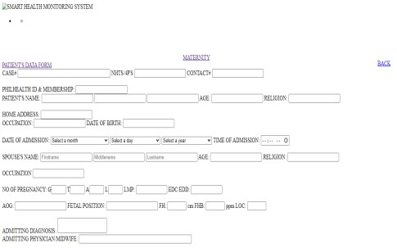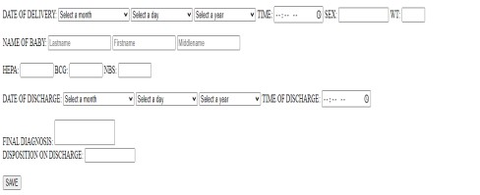

**PATIENT DATA PAGE CODE:**

<!DOCTYPE html>

<?php require_once'logincheck.php';

$conn = new mysqli("localhost", "root", "", "hcpms") or die(mysqli_error());

?>

<html lang = "en">

<head>

<title>Health Center Patient Record Management System</title>

<meta charset = "UTF-8">

<meta name="viewport" content="width=device-width, initial-scale=1">

<link rel = "shortcut icon" href = "images/logo.png" />

<link rel = "stylesheet" type = "text/css" href = "css/bootstrap.css" />

<link rel = "stylesheet" type = "text/css" href =

"css/jquery.dataTables.css" />

<link rel = "stylesheet" type = "text/css" href = "css/customize.css" />

</head>

<body>

<div class = "navbar navbar-default navbar-fixed-top">

<img src = "images/logo.png" style = "float:left;" height = "55px"

/><label class = "navbar-brand">SMART HEALTH MONITORING SYSTEM</label>

<ul class = "nav navbar-right">

<li class = "dropdown">

<a class = "user dropdown-toggle" data-toggle = "dropdown" href

= "#">

<span class = "glyphicon glyphicon-user"></span>

<?php echo $fetch['firstname']." ".$fetch['lastname'] ?>

<b class = "caret"></b>

</a>

<ul class = "dropdown-menu">

<li>

<a class = "me" href = " ">

</li>

</ul>

</li>

</ul>

</div>

<br />

<br />

<br />

<div class = "well">

<div class = "panel panel-warning">

<div class = "panel-heading">

<center><label>MATERNITY</label></center>

</div>

</div>

<div class = "panel panel-default">

<div class = "panel-heading">

<label>PATIENT'S DATA FORM</label> <a style = "float:right;

margin-top:-4px;" href = "birthing_pending.php?id=<?php echo $_GET['id']?>&lastname=<?php echo $_GET['lastname']?>" class = "btn btn-info"><span class = "glyphicon glyphicon-hand-right"></span> BACK</a>

</div>

<form method = "POST" enctype = "multipart/form-data">

<?php

?>

<div class = "panel-body">

<div class = "form-inline">

<label>CASE#</label>

<input type = "text" size = "40"class = "form-control" name =

"case_no" required = "required"/>

<label>NHTS/4P'S</label>

<input type = "text" class = "form-control" name = "nhts" />

<label>CONTACT#</label>

<input type = "text" class = "form-control" name = "contact" />

</div>

<br />

<div class = "form-group">

<label>PHILHEALTH ID & MEMBERSHIP:</label>

<input type = "text" value = " " name = "philhealth" class =

"form-control" />

</div>

<div class = "form-inline">

<label>PATIENT'S NAME:</label>

<input type = "text" class = "form-control" name =

"pat_firstname" value = " " placeholder = "Firstname" required = "required" />

<input type = "text" class = "form-control" name =

"pat_middlename" value = " " placeholder = "Middlename" />

<input type = "text" class = "form-control" name =

"pat_lastname" value = " " placeholder = "Lastname" required = "required" /> <label>AGE:</label>

<input type = "number" class = "form-control" value = " " name

= "age" required = "required" />

<label>RELIGION:</label>

<input type = "text" class = "form-control" name = "religion"

required = "required" />

</div> <br />

<div class = "form-group">

<label>HOME ADDRESS:</label>

<input type = "text" class = "form-control" value = " " name =

"address" />

</div>

<div class = "form-inline">

<label>OCCUPATION:</label>

<input type = "text" class = "form-control" name = "occupation"

/>

<label>DATE OF BIRTH:</label>

<input type = "text" name = "date_of_birth" class =

"form-control" value = " " />

</div>

<br />

<div class = "form-inline">

<label>DATE OF ADMISSION:</label>

<select name = "admission_month" style = "width:15%;" class

= "form-control" required = "required">

<option value = "">Select a month</option>

<option value = "01">January</option>

<option value = "02">February</option>

<option value = "03">March</option>

<option value = "04">April</option>

<option value = "05">May</option>

<option value = "06">June</option>

<option value = "07">July</option>

<option value = "08">August</option>

<option value = "09">September</option>

<option value = "10">October</option>

<option value = "11">November</option>

<option value = "12">December</option>

</select>

<select name = "admission_day" class = "form-control" style

= "width:13%;" required = "required">

<option value = "">Select a day</option>

<option value = "01">01</option>

<option value = "02">02</option>

<option value = "03">03</option>

<option value = "04">04</option>

<option value = "05">05</option>

<option value = "06">06</option>

<option value = "07">07</option>

<option value = "08">08</option> <option value = "09">09</option>

<?php

$a = 10; while($a <= 31){ echo "<option value = '".$a."'>".$a++."</option>";

}

?>

</select>

<select name = "admission_year" class = "form-control" style

= "width:13%;" required = "required">

<option value = "">Select a year</option>

<?php

$a = date(Y); while(1965 <= $a){ echo "<option value = '".$a."'>".$a--."</option>";

}

?>

</select>

<label>TIME OF ADMISSION:</label>

<input type = "time" name = "time_of_admission" class =

"form-control" />

</div>

<br />

<div class = "form-inline">

<label>SPOUSE'S NAME:</label>

<input type = "text" class = "form-control" name =

"spouse_firstname" placeholder = "Firstname" required = "required" />

<input type = "text" class = "form-control" name =

"spouse_middlename" placeholder = "Middlename" />

<input type = "text" class = "form-control" name =

"spouse_lastname" placeholder = "Lastname" required = "required" /> <label>AGE:</label>

<input type = "number" class = "form-control" name =

"spouse_age" required = "required" />

<label>RELIGION:</label>

<input type = "text" class = "form-control" name =

"spouse_religion" required = "required" />

</div>

<br />

<div class = "form-inline">

<label>OCCUPATION</label>

<input type = "text" name = "spouse_occupation" class =

"form-control" />

</div> <br />

<div class = "form-inline">

<label>NO OF PREGNANCY:</label>

<label>G</label><input type = "text" size = "2" name = "g"

class = "form-control" />

<label>T</label><input type = "text" size = "2" name = "t"

class = "form-control" />

<label>A</label><input type = "text" size = "2" name = "a"

class = "form-control" />

<label>L</label><input type = "text" size = "2" name = "l"

class = "form-control" />

<label>LMP:</label>

<input type = "text" size = "10" name = "lmp" class =

"form-control" />

<label>EDC/EDD:</label>

<input type = "text" size = "10" name = "edc" class =

"form-control" />

</div>

<br />

<div class = "form-inline">

<label>AOG:</label>

<input type = "text" name = "aog" class = "form-control"/>

<label>FETAL POSITION:</label>

<input type = "text" name = "fetal_position" class =

"form-control"/>

<label>FH:</label>

<input type = "text" name = "fh" size = "4" class =

"form-control"/>

<label>cm FHB:</label>

<input type = "text" name = "fhb" size = "4" class =

"form-control"/>

<label>ppm LOC:</label>

<input type = "text" name = "loc" size = "4" class =

"form-control"/>

</div>

<br />

<div class = "form-group">

<label>ADMITTING DIAGNOSIS:</label>

<textarea name = "admitting_diagnosis" style = "resize:none;"

class = "form-control"></textarea>

</div>

<div class = "form-inline">

<label>ADMITTING PHYSICIAN/MIDWIFE:</label>

<input type = "text"class = "form-control" name = "midwife"

size = "50" required = "required"/>

</div> <br />

<div class = "form-inline">

<label>DATE OF DELIVERY:</label>

<select name = "delivery_month" style = "width:15%;" class =

"form-control" required = "required">

<option value = "">Select a month</option>

<option value = "01">January</option>

<option value = "02">February</option>

<option value = "03">March</option>

<option value = "04">April</option>

<option value = "05">May</option>

<option value = "06">June</option>

<option value = "07">July</option>

<option value = "08">August</option>

<option value = "09">September</option>

<option value = "10">October</option>

<option value = "11">November</option>

<option value = "12">December</option>

</select>

<select name = "delivery_day" class = "form-control" style =

"width:13%;" required = "required">

<option value = "">Select a day</option>

<option value = "01">01</option>

<option value = "02">02</option>

<option value = "03">03</option>

<option value = "04">04</option>

<option value = "05">05</option>

<option value = "06">06</option>

<option value = "07">07</option>

<option value = "08">08</option> <option value = "09">09</option>

<?php

$a = 10; while($a <= 31){ echo "<option value = '".$a."'>".$a++."</option>";

}

?>

</select>

<select name = "delivery_year" class = "form-control" style

= "width:13%;" required = "required">

<option value = "">Select a year</option>

<?php

$a = date(Y); while(1965 <= $a){ echo "<option value = '".$a."'>".$a--."</option>";

}

?>

</select>

<label>TIME:</label>

<input type = "time" class = "form-control" name = "time1"

style = "width:10%;" required = "required"/>

<label>SEX:</label>

<input type = "text" class = "form-control" name = "sex" style

= "width:10%;" required = "required"/>

<label>WT:</label>

<input type = "text" class = "form-control" name = "wt" size =

"4" required = "required"/>

</div> <br />

<div class = "form-inline">

<label>NAME OF BABY:</label>

<input type = "text" class = "form-control" name =

"baby_lastname" placeholder = "Lastname" required = "required" />

<input type = "text" class = "form-control" name =

"baby_firstname" placeholder = "Firstname" />

<input type = "text" class = "form-control" name =

"baby_middlename" placeholder = "Middlename" required = "required" />

</div>

<br />

<div class = "form-inline">

<label>HEPA:</label>

<input type = "text" class = "form-control" name = "hepa" size

= "8" required = "required" />

<label>BCG:</label>

<input type = "text" class = "form-control" name = "bcg" size =

"8" required = "required" />

<label>NBS:</label>

<input type = "text" class = "form-control" name = "nbs" size =

"8" required = "required" />

</div> <br />

<div class = "form-inline">

<label>DATE OF DISCHARGE:</label>

<select name = "date_month" style = "width:15%;" class =

"form-control" required = "required">

<option value = "">Select a month</option>

<option value = "01">January</option>

<option value = "02">February</option>

<option value = "03">March</option>

<option value = "04">April</option>

<option value = "05">May</option>

<option value = "06">June</option>

<option value = "07">July</option>

<option value = "08">August</option>

<option value = "09">September</option>

<option value = "10">October</option>

<option value = "11">November</option>

<option value = "12">December</option>

</select>

<select name = "date_day" class = "form-control" style =

"width:13%;" required = "required">

<option value = "">Select a day</option>

<option value = "01">01</option>

<option value = "02">02</option>

<option value = "03">03</option>

<option value = "04">04</option>

<option value = "05">05</option>

<option value = "06">06</option>

<option value = "07">07</option>

<option value = "08">08</option> <option value = "09">09</option>

<?php

$a = 10; while($a <= 31){ echo "<option value = '".$a."'>".$a++."</option>";

}

?>

</select>

<select name = "date_year" class = "form-control" style =

"width:13%;" required = "required">

<option value = "">Select a year</option>

<?php

$a = date(Y); while(1965 <= $a){ echo "<option value = '".$a."'>".$a--."</option>";

}

?>

</select>

<label>TIME OF DISCHARGE:</label>

<input type = "time" class = "form-control" name =

"time_of_discharge" style = "width:10%;" required = "required"/>

</div>

<br />

<div class = "form-group">

<label>FINAL DIAGNOSIS:</label>

<textarea name = "final_diagnosis" style = "resize:none;" class

= "form-control"></textarea>

</div>

<div class = "form-inline">

<label>DISPOSITION ON DISCHARGE:</label>

<input type = "text" class = "form-control" name =

"disposition_on_discharge" style = "width:10%;" required = "required"/>

<input type = "hidden" value = "<?php echo $_GET['id']?>" name

= "itr_no" />

<input type = "hidden" value = "<?php echo

$_SESSION['user_id']?>" name = "user_id" />

</div>

<br />

<div class = "form-inline">

<button class = "btn btn-primary" name = "save_patient" ><span

class = "glyphicon glyphicon-save"></span> SAVE</button>

</div> </div>

<?php require 'add_query.php'?>

</form>

</div>

</div>

<div id = "footer">

<label class = "footer-title">

</div>

</body>

<?php require "script.php" ?>

</html>

**BIRTHING FORM PAGE:** **BIRTHING FORM PAGE CODE:**

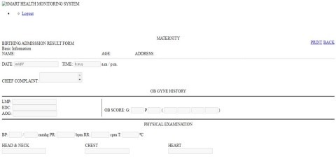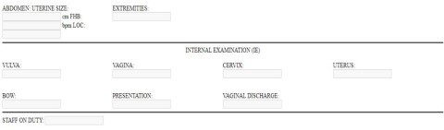

<!DOCTYPE html>

<?php

require_once'logincheck.php';

?>

<html lang = "en">

<head>

<title>SMART HEALTH MONITORING SYSTEM</title>

<meta charset = "UTF-8">

<meta name="viewport" content="width=device-width, initial-scale=1">

<link rel = "shortcut icon" href = "images/logo.png" />

<link rel = "stylesheet" type = "text/css" href = "css/bootstrap.css" />

<link rel = "stylesheet" type = "text/css" href = "css/jquery.dataTables.css" />

<link rel = "stylesheet" type = "text/css" href = "css/customize.css" />

</head>

<body>

<div class = "navbar navbar-default navbar-fixed-top">

<img src = "images/logo.png" height = "55px" style = "float:left;"><label class

= "navbar-brand">SMART HEALTH MONITORING SYSTEM</label> <ul class =

"nav navbar-right">

<li class = "dropdown">

<a class = "user dropdown-toggle" data-toggle = "dropdown" href = "#">

<span class = "glyphicon glyphicon-user"></span>

<?php echo $fetch['firstname']." ".$fetch['lastname'] ?>

<b class = "caret"></b>

</a>

<ul class = "dropdown-menu">

<li>

<a class = "me" href = "logout.php"><span class = "glyphicon

glyphicon-log-out"></span> Logout</a>

</li>

</ul>

</li>

</ul>

</div>

<br />

<br />

<br />

<div class = "well">

<div class = "panel panel-warning">

<div class = "panel-heading">

<center><label>MATERNITY</label></center>

</div>

</div>

<div class = "panel panel-default">

<div class = "panel-heading">

<label>BIRTHING ADMISSSION RESULT FORM</label>

<a style = "float:right; margin-top:-4px;" href =

"birthing_record.php?itr_no=<?php echo $f2['itr_no']?>" class = "btn btn-info"><span class = "glyphicon glyphicon-hand-right"></span> BACK</a>

<a style = "margin-right:5px; float:right; margin-top:-4px;" href =

"birthing_print.php?itr_no=<?php echo $f2['itr_no']?>&birth_id=<?php echo $_GET['birth_id']?>" class = "btn btn-info"><span class = "glyphicon glyphicon-print"></span> PRINT</a>

</div>

<form method = "POST" enctype = "multipart/form-data">

<div class = "panel-body">

<div class = "alert alert-info">Basic Information</div>

<div style = "float:left; width:30%;">

<label>NAME:</label>

<br />

<label class = "text-muted"><?php echo $f2['firstname']."

".substr($f2['middlename'], 0,1).". ".$f2['lastname']?></label>

</div>

<div style = "width:10%; float:left;">

<label>AGE:</label>

<br />

<label class = "text-muted"><?php echo $f2['age']?></label>

</div>

<div style = "float:left; width:40%;">

<label>ADDRESS:</label>

<br />

<label class = "text-muted"><?php echo $f2['address']?></label>

</div>

<br style = "clear:both;"/>

<hr style = "border:1px dotted #d3d3d3;" />

<div class = "form-inline">

<label>DATE:</label>

<input type = "text" class = "form-control" disabled = "disabled"

value = "m/d/Y">

<label style = "margin-left:10px;">TIME:</label>

<input type = "text" class = "form-control" disabled = "disabled"

size = "10" value = "h:m:s">

<label>a.m / p.m.</label>

</div>

<br />

<div class = "group">

<label>CHIEF COMPLAINT:</label>

<textarea name = "chief_complaint" disabled = "disabled" class =

"form-control" style = "resize:none;">

<div class = "form-group">

<label>HISTORY:</label>

<textarea name = "history" disabled = "disabled" class = "form-control" style = "resize:none;"><?php echo $f['history']?></textarea>

</div>

<br />

<center><label>OB GYNE HISTORY</label></center>

<hr style = "border:1px solid #000;" />

<div class = "form-inline" style = " border-right:1px solid #000;

height:100%; width:30%; float:left;">

<label>LMP:</label>

<input type = "text" disabled = "disabled" value = " " name = " "

class = "form-control" />

<br />

<label>EDC:</label>

<input style = "margin-left:2px;" disabled = "disabled" value = "

" type = "text" name = "edc" class = "form-control" />

<br />

<label>AOG:</label>

<input type = "text" name = "aog" disabled = "disabled" value = "

" class = "form-control" />

</div>

<div class = "form-inline" style = "width:60%; margin-left:10px;

margin-top:30px; float:left;">

<label>OB SCORE:</label>

<label>G:</label>

<input type = "text" name = "g" disabled = "disabled" value = " "

size = "2" class = "form-control" />

<label>P</label>

<input type = "text" name = "p" disabled = "disabled" value = " "

size = "2" class = "form-control" />

<label>(</label>

<input type = "text" name = "1" disabled = "disabled" value = " "

size = "2" class = "form-control" />

<input type = "text" name = "2" disabled = "disabled" value = " "

size = "2" class = "form-control" />

<input type = "text" name = "3" disabled = "disabled" value = " "

size = "2" class = "form-control" />

<input type = "text" name = "4" disabled = "disabled" value = " "

size = "2" class = "form-control" />

<label>)</label>

</div>

<br style = "clear:both;"/>

<hr style = "border:1px solid #000;" />

<center><label>PHYSICAL EXAMINATION</label></center>

<br />

<div class = "form-inline">

<label>BP:</label>

<input type = "text" name = "bp1" disabled = "disabled" value =

" " size = "2" class = "form-control" />

<label>/</label>

<input type = "text" name = "bp2" size = "2" disabled =

"disabled" value = " " class = "form-control" />

<label>mmhg PR:</label>

<input type = "text" name = "pr" disabled = "disabled" value = "

" size = "5" class = "form-control" />

<label>bpm RR:</label>

<input type = "text" name = "rr" disabled = "disabled" value = " "

size = "5" class = "form-control" />

<label>cpm T:</label>

<input type = "text" name = "t" disabled = "disabled" value = " "

size = "4" class = "form-control" />

<label>⁰C</label>

</div>

<br />

<div class = "form-inline" style = "width:25%; float:left;">

<label>HEAD & NECK</label>

<br />

<input type = "text" name = "head_neck" disabled = "disabled"

value = " " class = "form-control" />

</div>

<div class = "form-inline" style = "width:25%; float:left;">

<label>CHEST</label>

<br />

<input type = "text" name = "chest" disabled = "disabled" value =

" " class = "form-control" />

</div>

<div class = "form-inline" style = "width:25%; float:left;">

<label>HEART</label>

<br />

<input type = "text" name = "heart" disabled = "disabled" value =

" " class = "form-control" />

</div>

<br />

<br />

<br />

<br style = "clear:both;"/>

<div class = "form-inline" style = "width:25%; float:left;">

<label>ABDOMEN: UTERINE SIZE:</label>

<input type = "text" name = "abdomen" disabled = "disabled"

value = " " class = "form-control" />

<label>cm FHB:</label>

<input type = "text" name = "fhb" disabled = "disabled" value = "

" class = "form-control" />

<label>bpm LOC:</label>

<input type = "text" name = "loc" disabled = "disabled" value = "

" class = "form-control" />

</div>

<div class = "form-inline" style = "width:25%; float:left;">

<label>EXTREMITIES:</label>

<br />

<input type = "text" name = "extremities" disabled = "disabled"

value = " " class = "form-control" />

</div>

<br style = "clear:both;"/>

<hr style = "border:1px solid #000;" />

<center><label>INTERNAL EXAMINATION

(IE)</label></center>

<br />

<div class = "form-inline" style = "width:25%; float:left;">

<label>VULVA:</label>

<br />

<input type = "text" name = "vulva" disabled = "disabled" value

= " " class = "form-control" />

</div>

<div class = "form-inline" style = "width:25%; float:left;">

<label>VAGINA:</label>

<br />

<input type = "text" name = "vagina" disabled = "disabled" value

= " " class = "form-control" />

</div>

<div class = "form-inline" style = "width:25%; float:left;">

<label>CERVIX:</label>

<br />

<input type = "text" name = "cervix" disabled = "disabled" value

= " " class = "form-control" />

</div>

<div class = "form-inline" style = "width:25%; float:left;">

<label>UTERUS:</label>

<br />

<input type = "text" name = "uterus" disabled = "disabled" value

= " " class = "form-control" />

</div>

<br />

<br />

<br />

<br style = "clear:both;"/>

<div class = "form-inline" style = "width:25%; float:left;">

<label>BOW:</label>

<br />

<input type = "text" name = "bow" disabled = "disabled" value =

" " class = "form-control" />

</div>

<div class = "form-inline" style = "width:25%; float:left;">

<label>PRESENTATION:</label>

<br />

<input type = "text" name = "presentation" disabled = "disabled"

value = " " class = "form-control" />

</div>

<div class = "form-inline" style = "width:25%; float:left;">

<label>VAGINAL DISCHARGE:</label>

<input type = "text" name = "vaginal_discharge" disabled =

"disabled" value = " " class = "form-control" />

</div>

<br style = "clear:both;"/>

<hr style = "border:1px solid #000;" />

<div class = "form-inline">

<label>STAFF ON DUTY:</label>

<input type = "text" name = "staff" disabled = "disabled" value = " " class = "form-control" />

</div>

<br />

</div>

</div>

</form>

</div>

<div id = "footer"> </div>

</body>

<?php require "script.php" ?>

</html>

**Result:**

Thus, the details of architectural design/framework/implementation along with the screenshots were provided.

**CONCLUSION**

Our project entitled in the name ‘Smart Health Monitoring system’ provides assistance to determine the possible disease in reference to symptoms. However the challenges are still unsolved. Models are prone to overfitting that may end up in wrong predictions. Diagnosis cannot be done merely in light of symptoms, there exist various factors concerned about the patient that can lead to diseases. They include lifestyle,gender, hereditary etc. Advancements have to be brought in models to predict the disease based on factors other than symptoms which aids doctors to rely on these models for efficient disease predictions.

**REFERENCES**

1. <https://link.springer.com/article/10.1007/s42979-020-00195-y>
2. <https://www.javatpoint.com/software-cost-estimation>
3. <https://www.javatpoint.com/software-engineering-entity-relationship-diagrams>
4. <https://www.geeksforgeeks.org/software-engineering-cocomo-model/>
5. <https://www.healthline.com/health/mental-health/top-healthy-lifestyle-iphone-android-apps>
6. <https://www.korewireless.com/news/5-benefits-of-remote-patient-monitoring>
7. <https://www.indiatoday.in/technology/features/story/how-aarogya-setu-works-and-how-it-compares-to-contact-tracing-apps-in-other-countries-1674966-2020-05-06>
8. <https://www.aarogyasetu.gov.in/>
9. <https://www.javatpoint.com/uml-collaboration-diagram>
10. <https://www.geeksforgeeks.org/functional-vs-non-functional-requirements/>